

Google Classroom

Student & Parent Guide
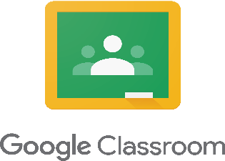

Contents of the Handbook



Google Classroom Etiquette

- Number of Rooms
- Registering
- Setting Work
- Marking Work
- Managing Workload
- ICT Issues

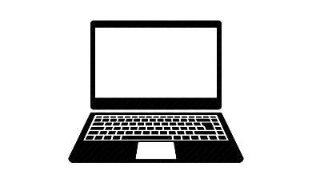
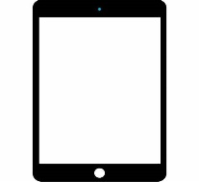

Using Google Classroom

Part 1 – Logging In, Joining a Room and the Sections to Google Classroom
Part 2 – Using the Stream
Part 3 – Using Classwork
Part 4 – Members of a Google Classroom
Part 5 – Assignments
Part 6 – Using Adobe Scan to Submit Hand-Written Work or Completed Worksheets
Part 7 – Accessing Feedback on Assignments
Part 8 – Managing All Your Assignments
Part 9 – Using Your Mobile Phone for Google Classroom

Introduction to Google Classroom & Etiquette

Google Classroom is a free web service VLE (Virtual Learning Environment) which has been developed by Google specifically for schools to facilitate e-Learning.

To access Google Classroom students can either do this from a PC / laptop or download the Google Classroom app to their smartphone / mobile device (like an iPad).

The Number of Google Classrooms


Students will have a separate google classroom of each of their subjects.

Registering for Google Classroom


Students and staff must only use their C2K email address to register with google classroom. This is for your own online safety and protection.


No personal email addresses should be used for any form of communication.


Any students who have joined with any personal email addresses will be asked to re-join using their C2k email address and will be deleted from the room.

Setting Work on Google Classroom


Work posted on Google Classroom should be saved onto pupils Google Drive.


Learning & teaching resources will be saved in Classwork.

Marking on Google Classroom


All homework will be set as an assignment with a specific date and time for submission.


All feedback on work will be communicated to students privately (not using the Stream).


Staff may mark and provide feedback on students work outside of school hours.

Managing Workload Using Google Classroom



Students should check google classroom notifications and their C2k school emails every day to ensure they receive all their work.


Students should inform their teachers if they having difficulties in completing work or meeting deadlines.

ICT Issues

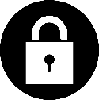
If a student needs to update an expired C2k password, they can do so at:

https://services.c2kni.net/ums


If a student is experiencing any other ICT problems, they can make contact with the ICT technicians if they are in school or email the school if they are at home:

cstott259@c2ken.net
mhutchinson069@c2ken.net

Part 1 – Accessing Google Classroom from a PC / Laptop & Joining Rooms

1) Go to the My School login portal (see the link below):
https://ids.c2kschools.net/nidp/idff/sso?id=3&sid=0&option=credential&sid=0

2) Login using your school login details (as you would in the ICT rooms in school)

3) Click on View All

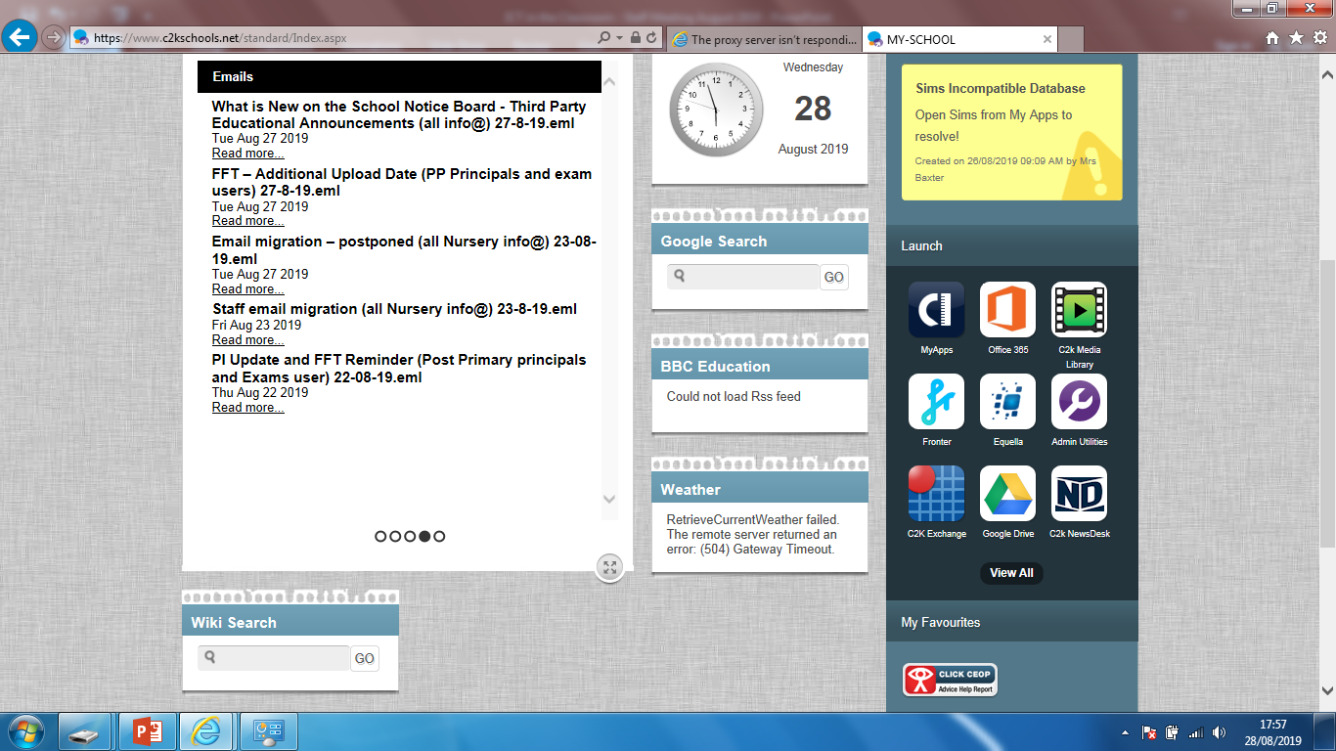

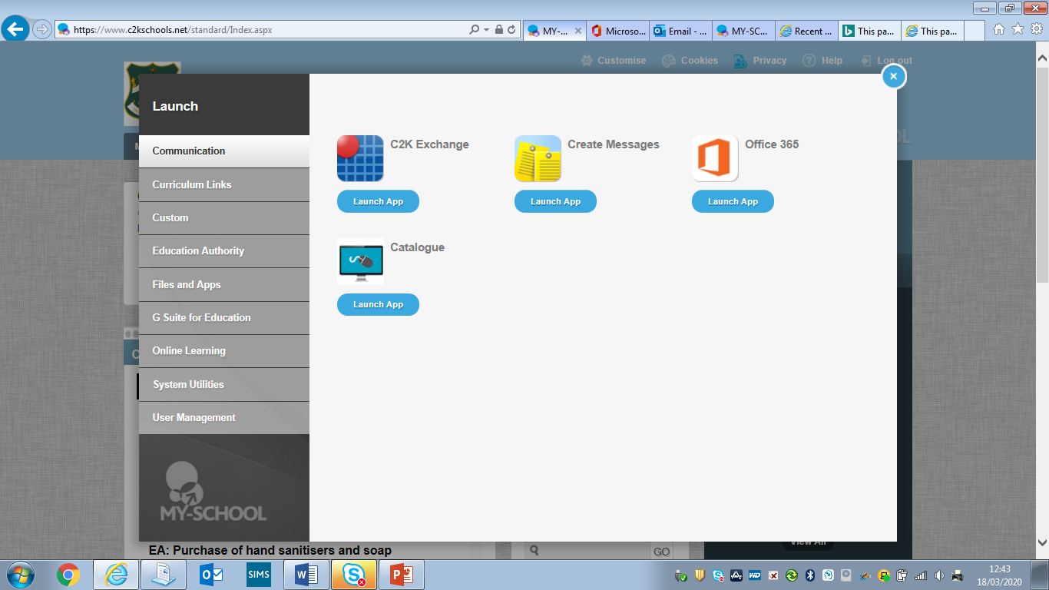
4) Click on G Suite for Education

5) Click on Google Classroom

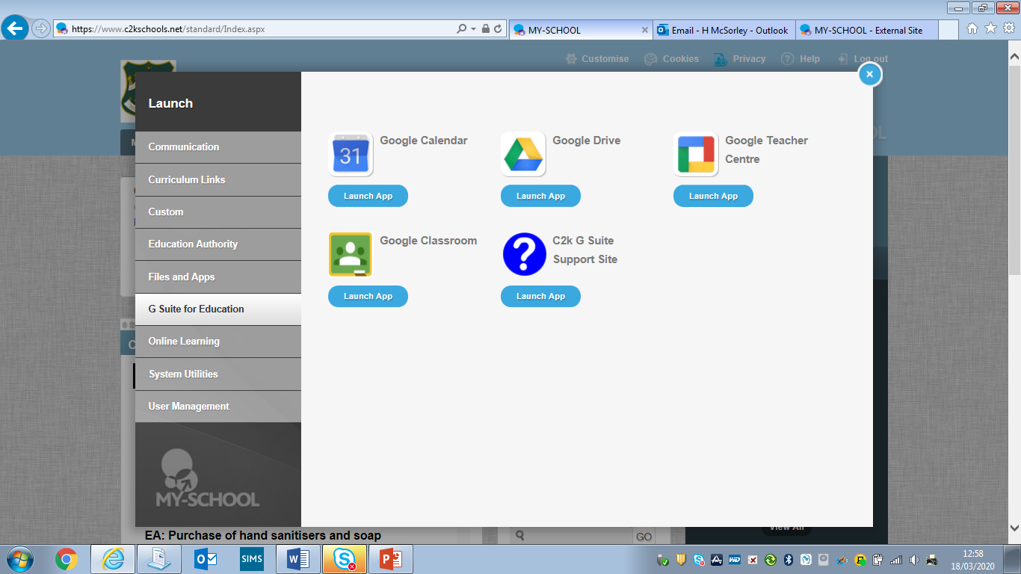

6) The following screen may appear and you will be prompted to sign in. Enter your school email address making sure it ends in @c2ken.net for example jbloggs818@c2ken.net Then type in your normal c2k password for logging on to the computers at school and click Sign in.

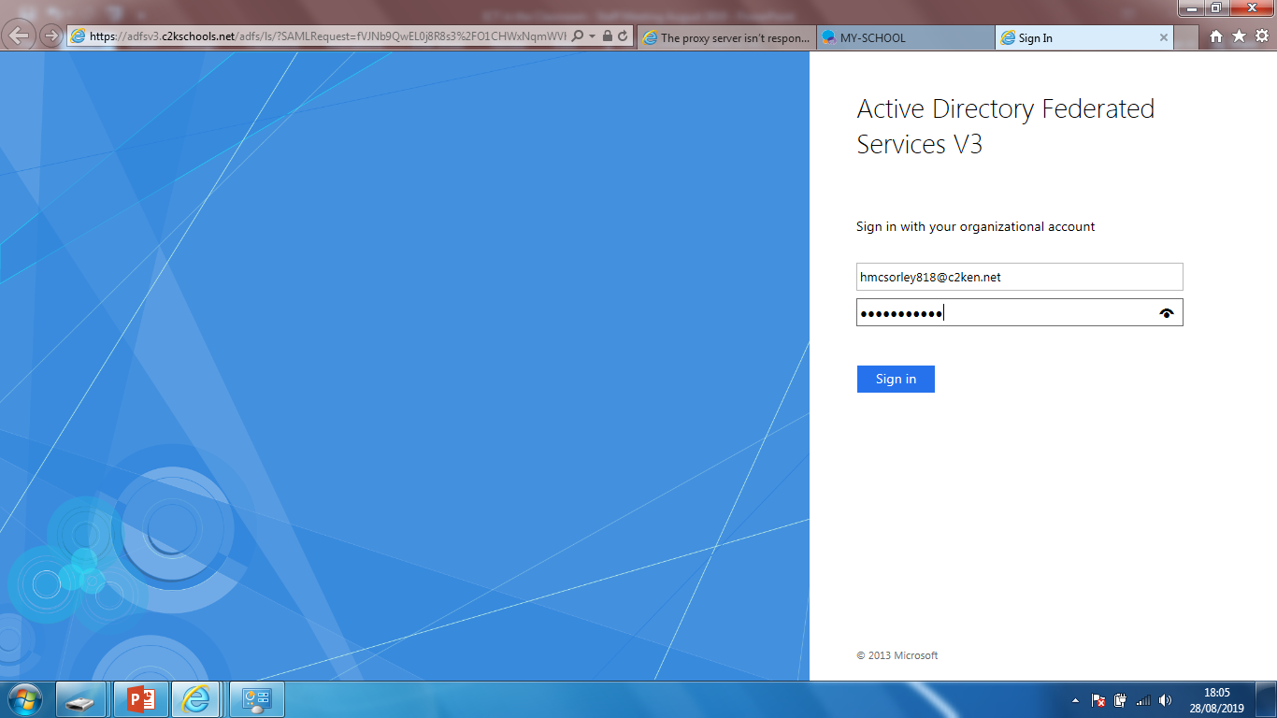

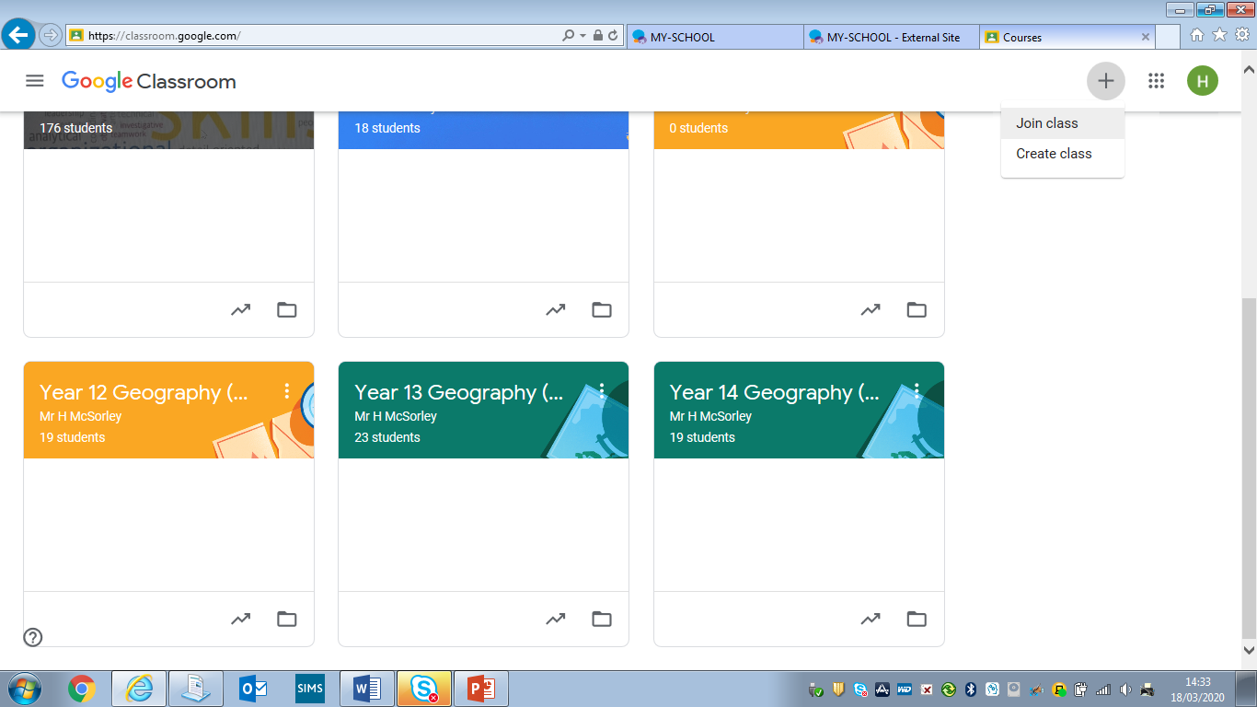
7) You will now be signed into Google Classroom. If you have joined any classes already you will be able to access them from here. To join a class, click on the + symbol at the top right of the page and Join Class.

8) Now enter the classroom code you have been given by your teacher and click on Join. You will now have access to this classroom and the resources contained within it.

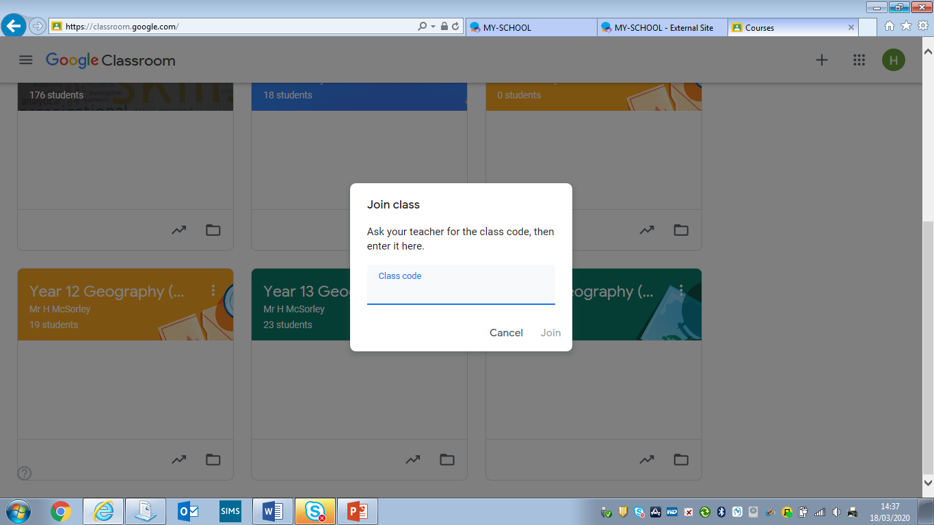

It is best to join classes initially using a laptop or PC as there can be some problem with joining classes uses a smart phone or tablet.

9) To open a classroom simply click on it.

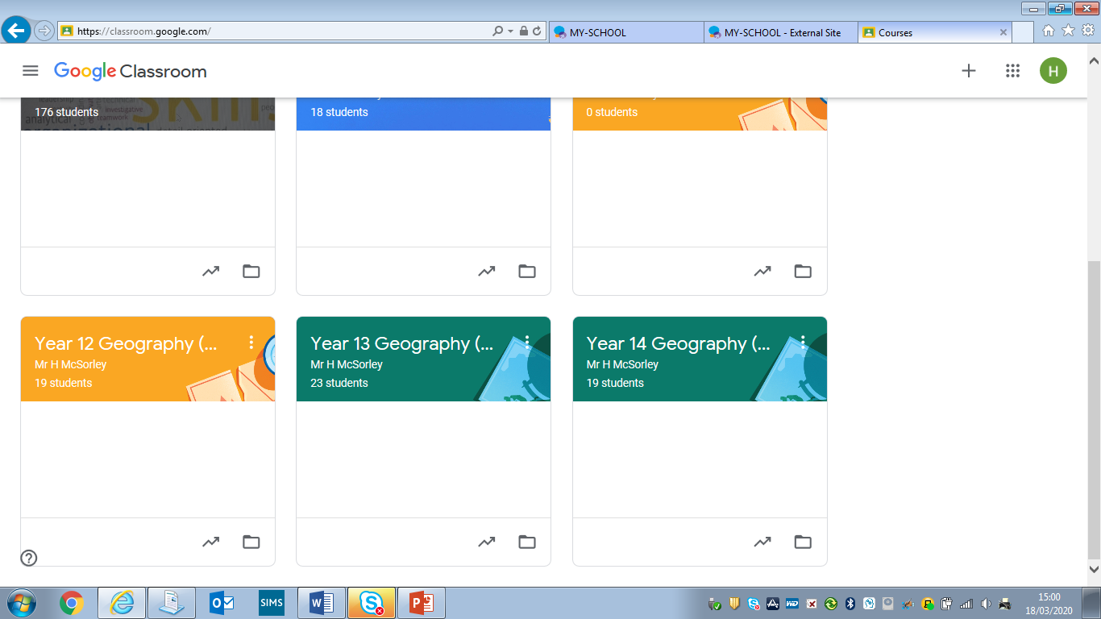

10) When you open a classroom you will automatically go to the Stream.

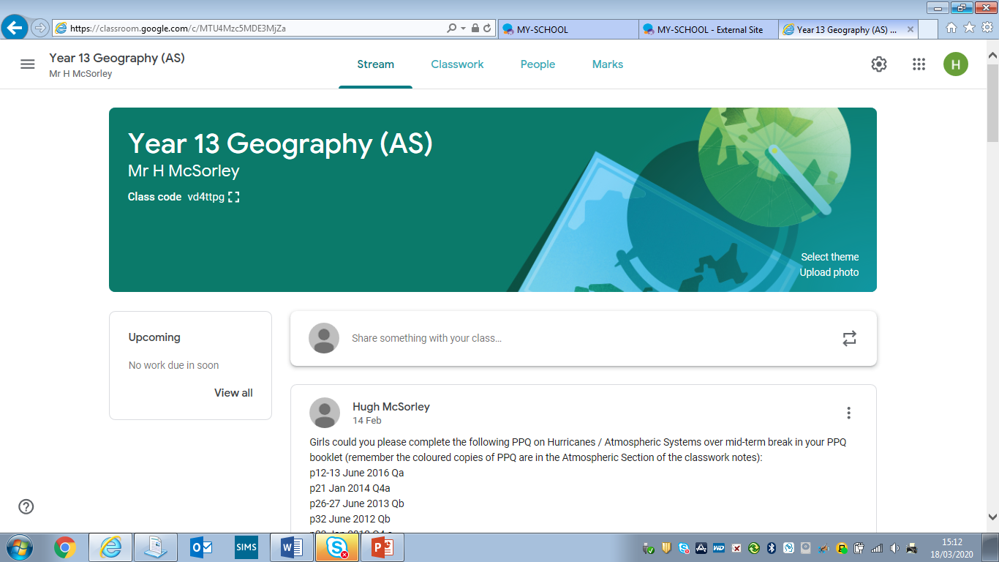

The Stream is a section in Google Classroom where your teachers can post instructions to you on the work you need to complete and post assignments for you to complete. Some teachers may also allow you to communicate with them, asking questions by replying to the messages they post. If your teachers allow this 2 way communication, please remember to be responsible at all times with your communication ensuring it is respectful and purposeful.

11) If you click on the Classwork tab you will go to the section of the room which contains the learning resources (notes, worksheets, research tasks, reading materials, powerpoints, video clips and website links) your teacher has saved for you. They will most likely be saved into different folders based on topics you are studying. To open a folder simply click on it to see all the resources contained within it.

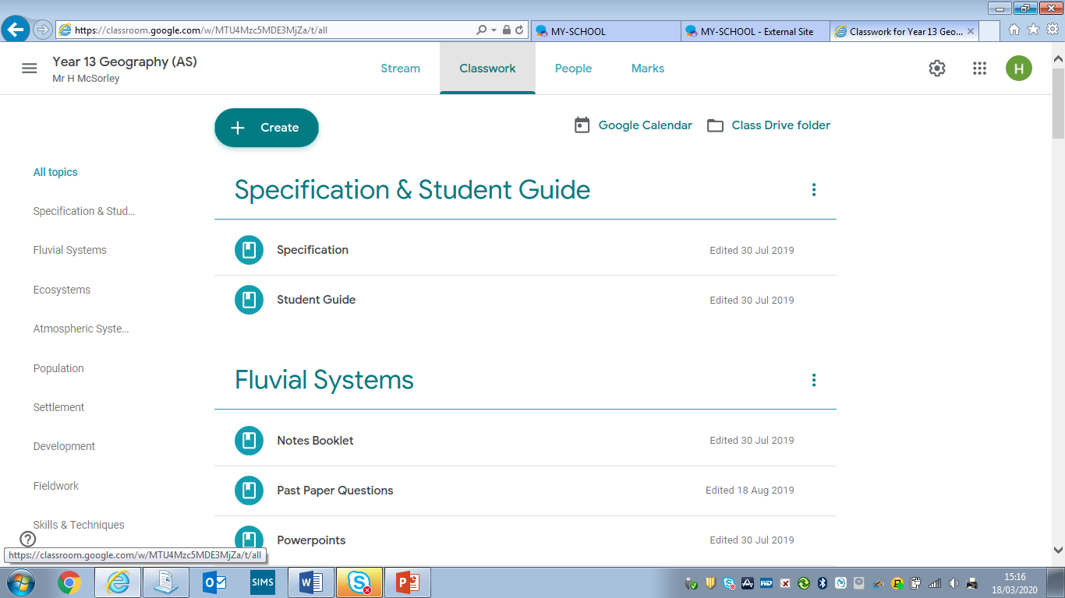

To open a document, video or weblink within a folder, simply click on it.

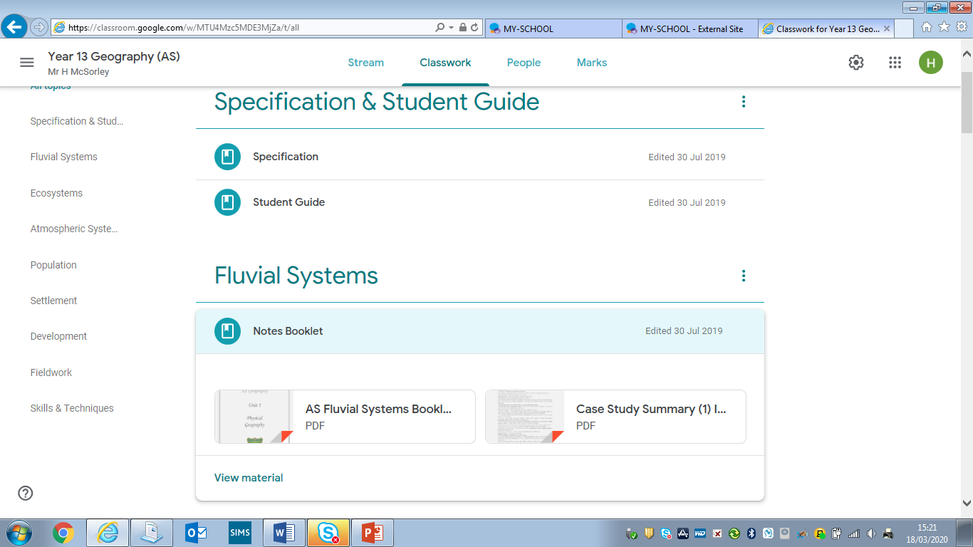

Part 2 - Using the Google Classroom Stream

The google classroom stream is for communication between staff and students which can be seen by everyone in the Google Classroom forum. It is therefore best used for sharing information and updates with classes. But it should not be used for providing feedback on individual students’ work. Some teachers may decide to remove students’ permission to comment in the Stream. If your teacher has given you access to the Stream – you can post messages, web-links or upload documents / files to the stream as a new post or under a post by someone else.

1) Click on the Stream tab at the top of the page.
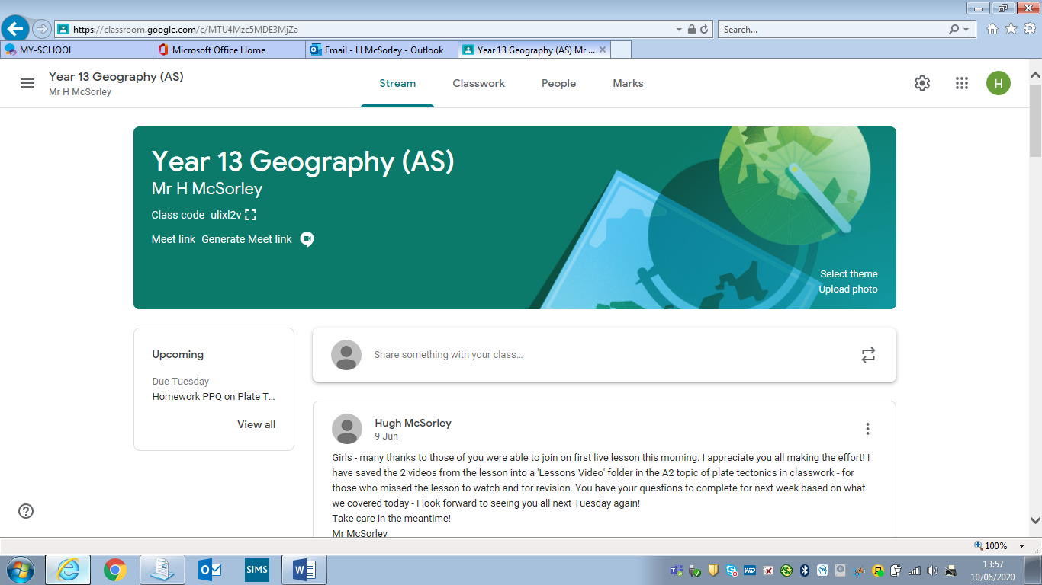

2) A box will appear at the top of the Stream page which notes “Share something with your class”. If you click on this and type, you can write a message which can be sent to everyone in the Google Classroom forum. (This option will not be available if your teacher has turned it off for students).

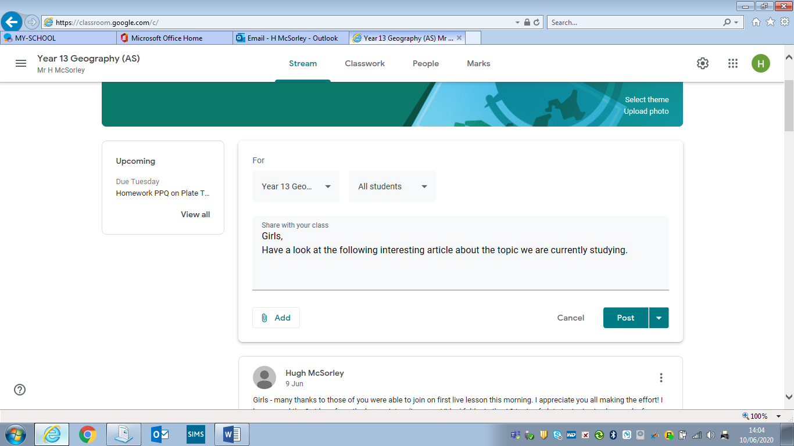
3) You can add a website link, document / file etc by clicking on Add.

4) To add a link to a website copy click on Link and paste the website address – the URL into the box that appears and click on Add Link.
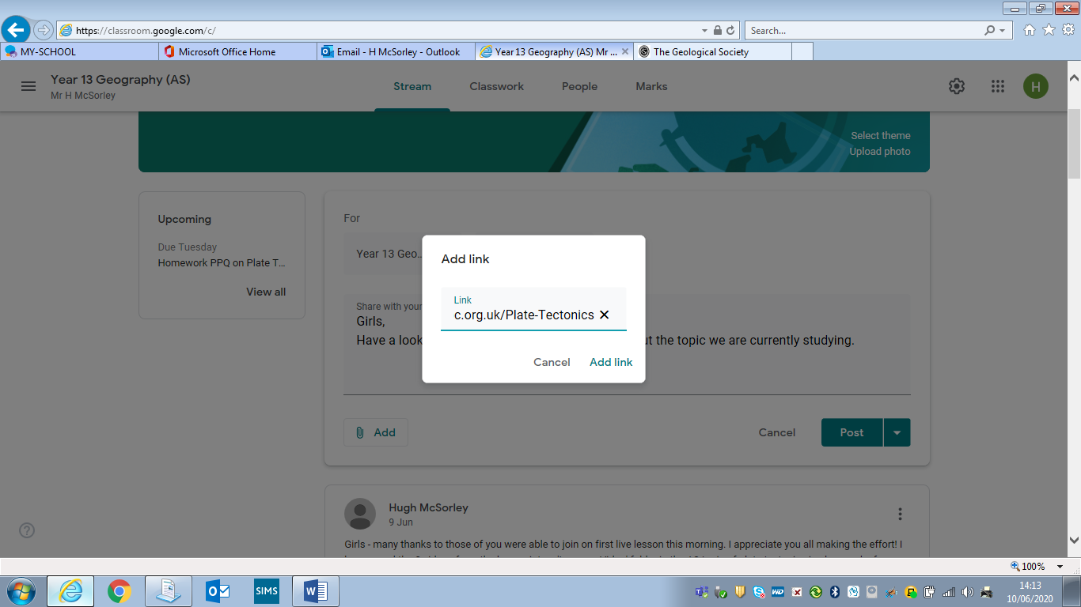

The website will now be added to your message like below. The same process is followed for adding in a link to a you tube video. Please ensure you always watch a video fully first and ensure it is appropriate before sharing it with others.
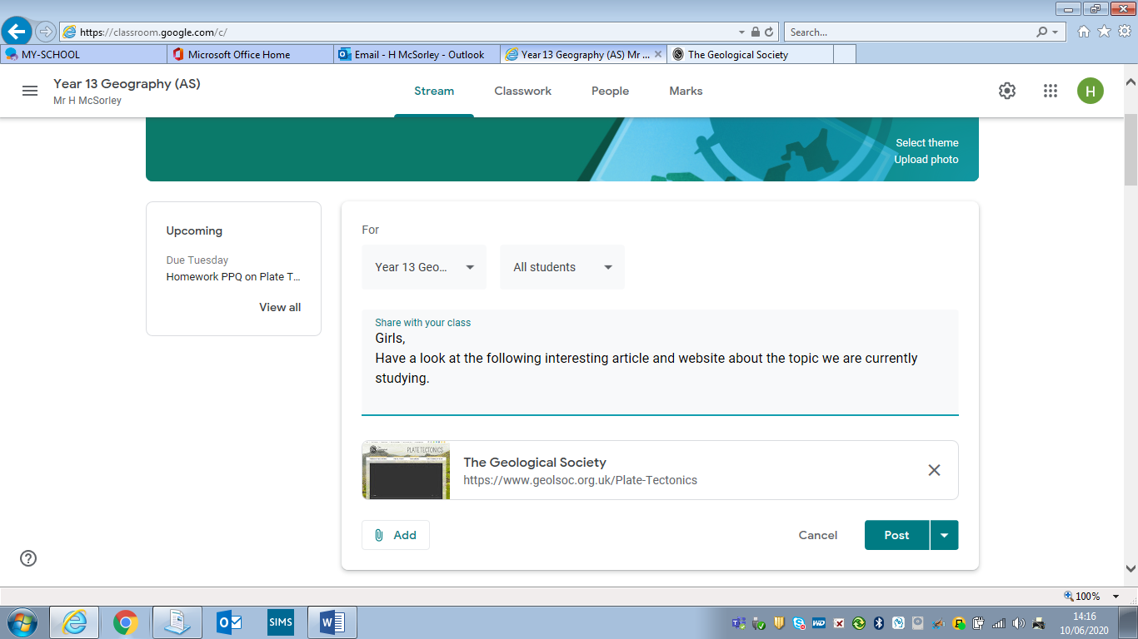
5) To add a document / file – click on Add.

6) Then click on File.
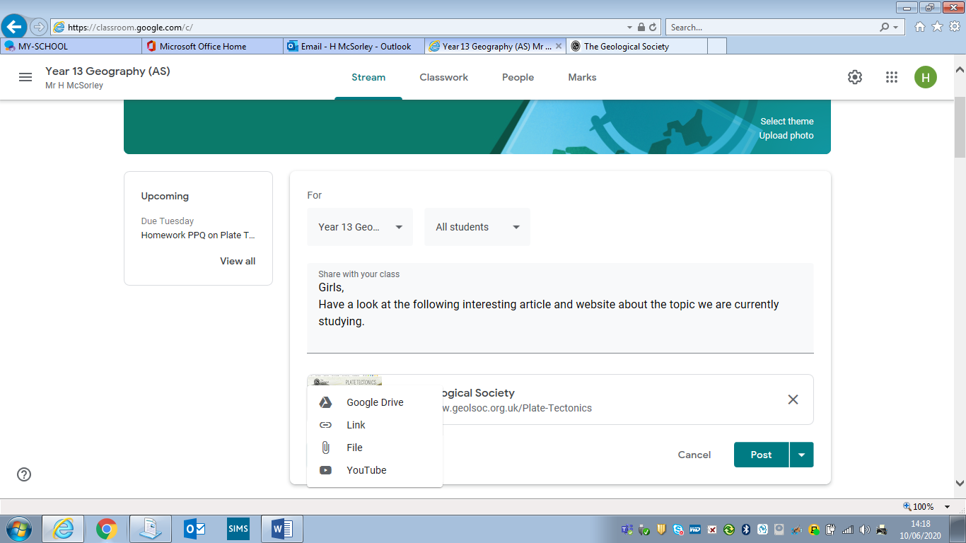

6) Click on Select files from your device.

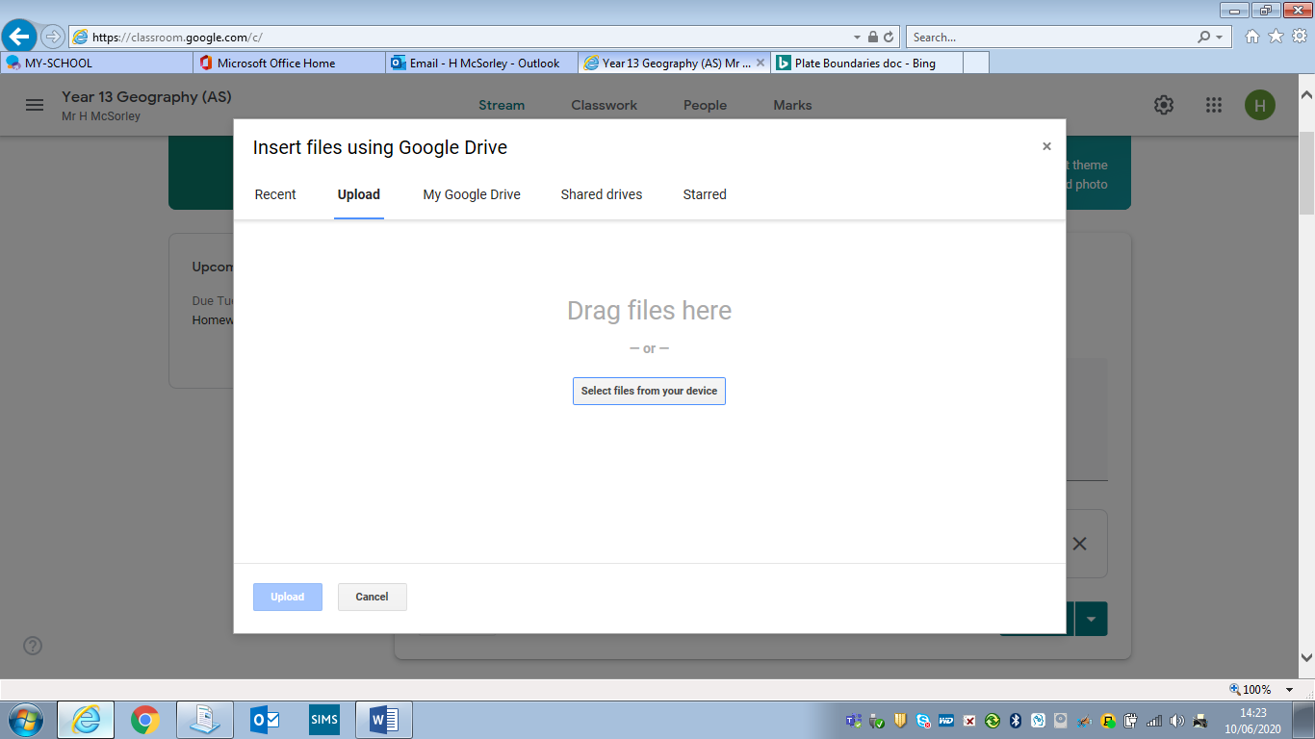

This will allow you to browse through the files saved to your computer or saved on a memory pen. When you have found the one you want to add click on it and click on Open.

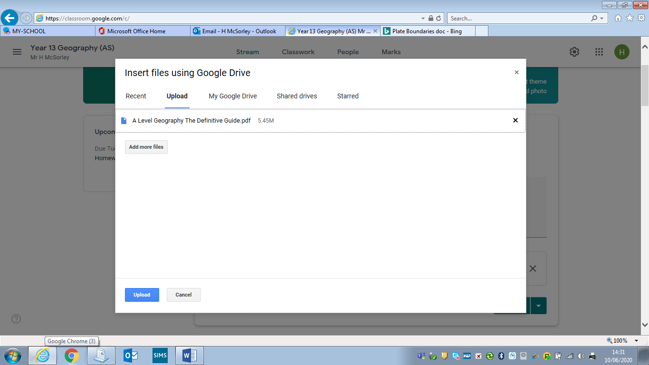
7) You can then add more files if you wish by clicking on Add more files and repeating the process.

8) Once you have added all the files you want to then click on Upload.

9) You will now get a preview of your message and the attachments you have added to it. To send it to everyone click on Post.
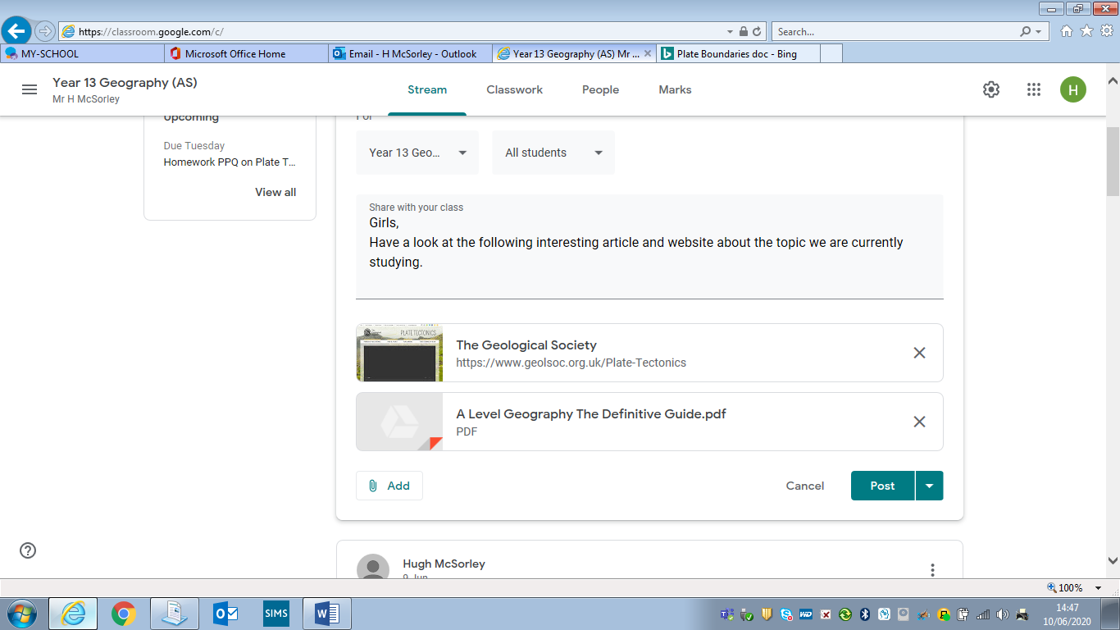

11) To read a message someone else has posted on the stream – simply click on it and it will expand to show you the full message. If there are any attachments such as a document or link to a website – again just click on them to open them.

Part 3 - Using the Google Classroom Classwork

1) As mentioned before if you click on the Classwork tab at the top of your google classroom you will go to the section of the room which contains the learning resources (notes, worksheets, research tasks, reading materials, powerpoints, video clips and website links) your teacher has saved for you. They will most likely be saved into different folders based on topics you are studying. To open a folder simply click on it. This will let you see all the documents, videos and links saved inside the folder.

2) To open a document, video or weblink simply click on it.

3) If want to save a copy of a document to your computer, when you have clicked on it to open it, there are 3 dots to the top right of the screen beside the printer icon. Click on this.
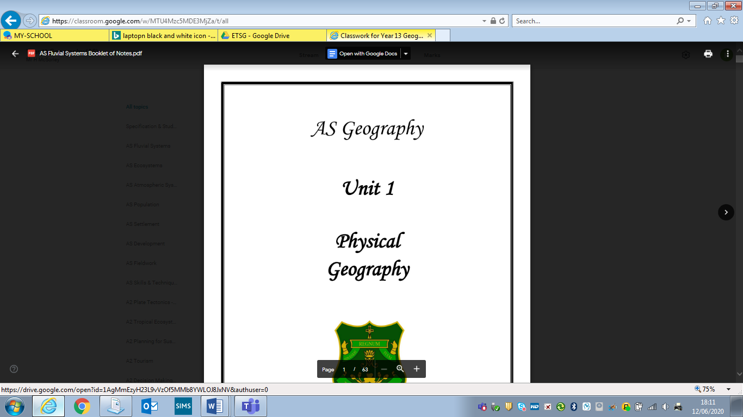

4) Now click on Open in New Window from the options provided.
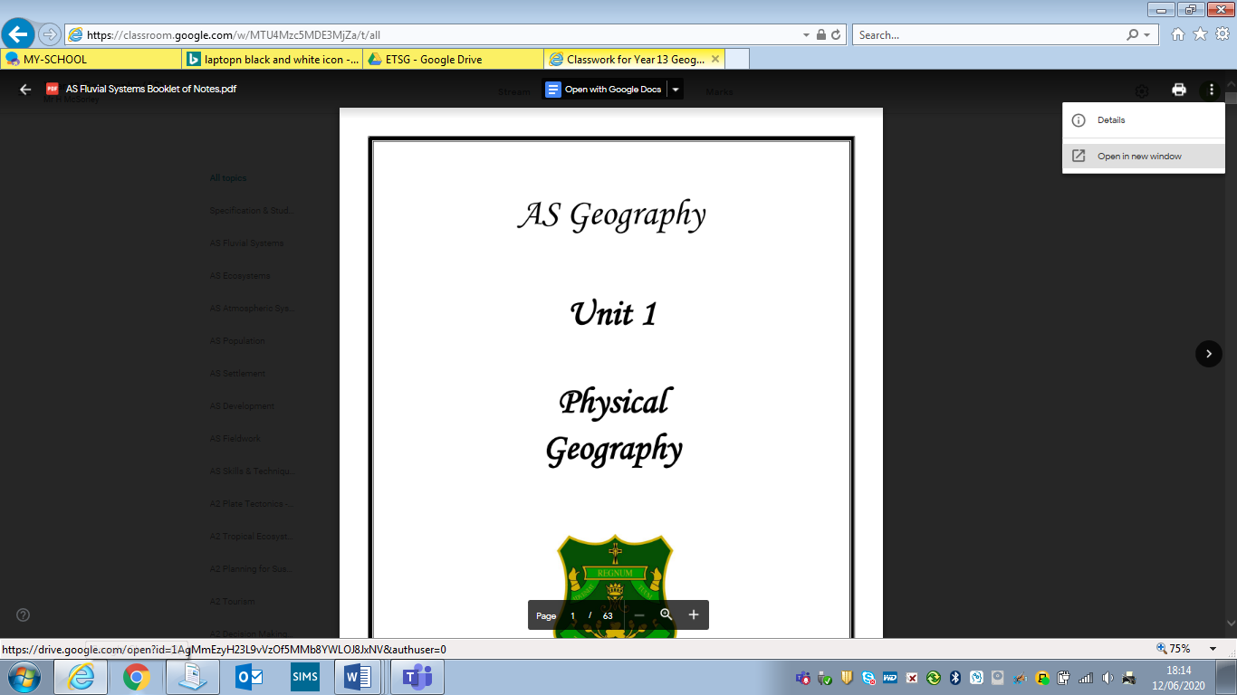

5) In the new screen that opens, click on the download icon at the top right of the screen.

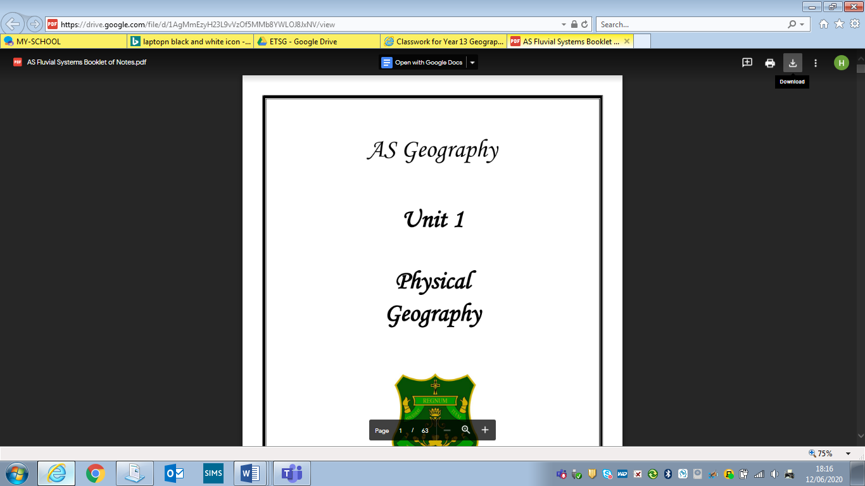

6) A message will appear at the bottom of your screen asking if you wish to open or save the document. Click on the arrow beside Save and click on Save As.

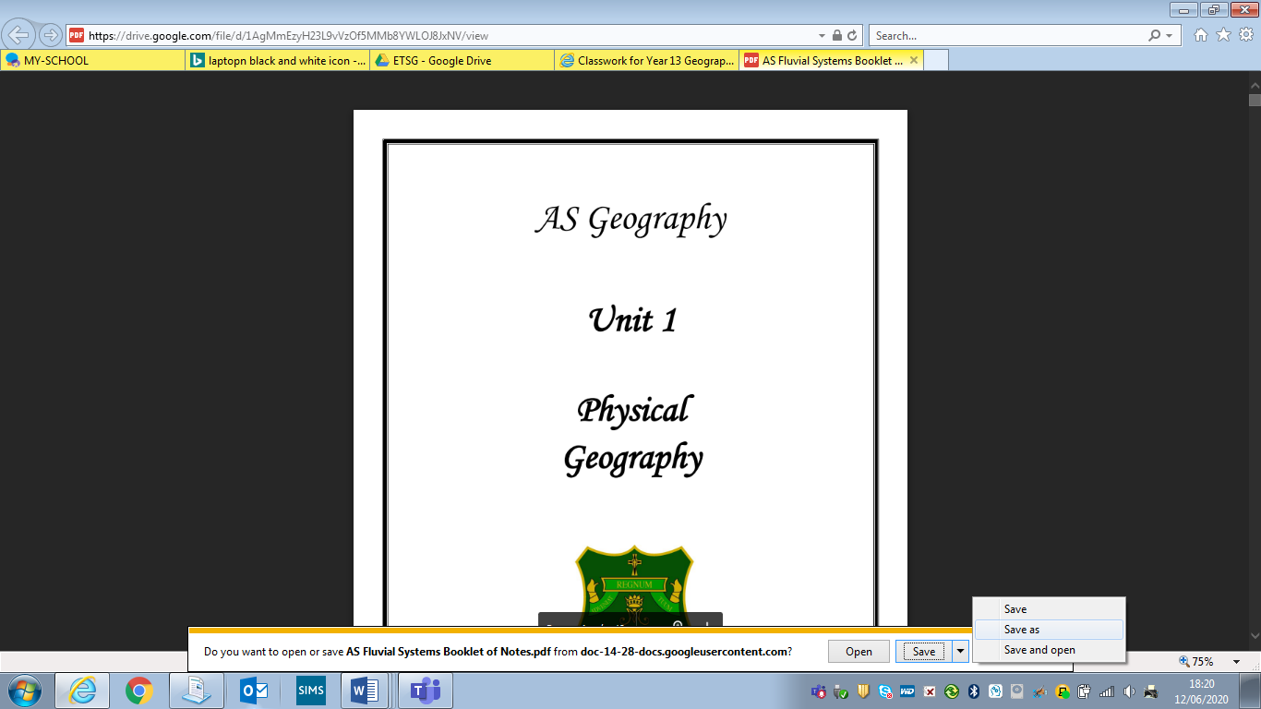

7) This will now give you the option of where you want to save the document to and what you want to call it.

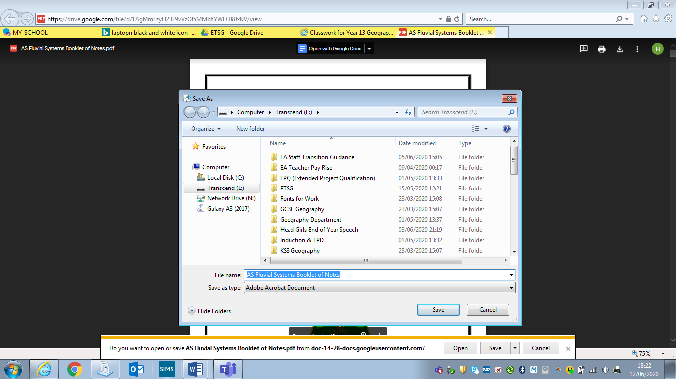

8) When you have chosen where you want to save the document and what to name it then click Save.

Part 4 – Members of Your Google Classroom

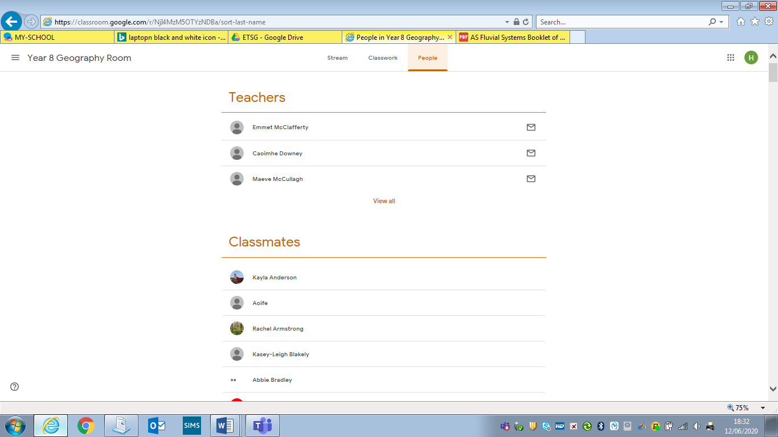
You can see the teachers and your classmates who are members of your google classroom. To do this click on the People tab at the top of your google classroom.

Part 5 – Assignments

1) When your teachers set you work to complete in google classroom they will set it as an Assignment.

2) This assignment will appear in Stream of the google classroom as well as the Classwork section of google classroom under the topic of work it is related to (if the teacher has tagged the assignment to this topic).

This is how an assignment / homework will appear as a notification on the Stream:
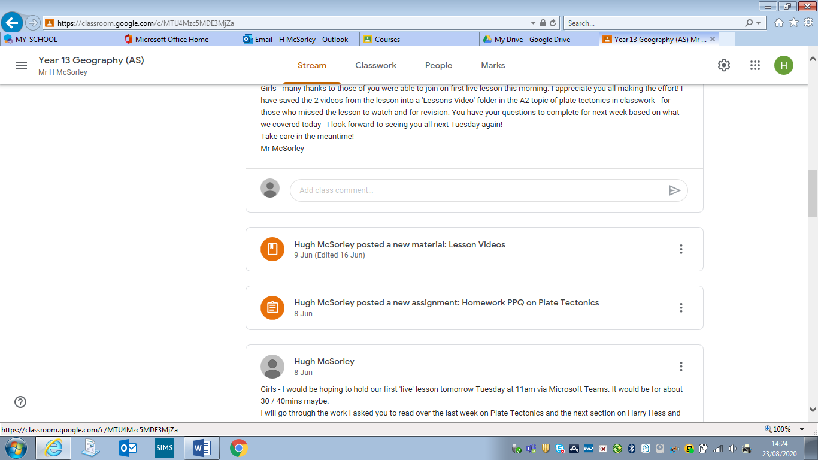
This is how the same assignment / homework will appear as a notification on Classwork under the topic of work it is related to (if the teacher has tagged the assignment to this topic):

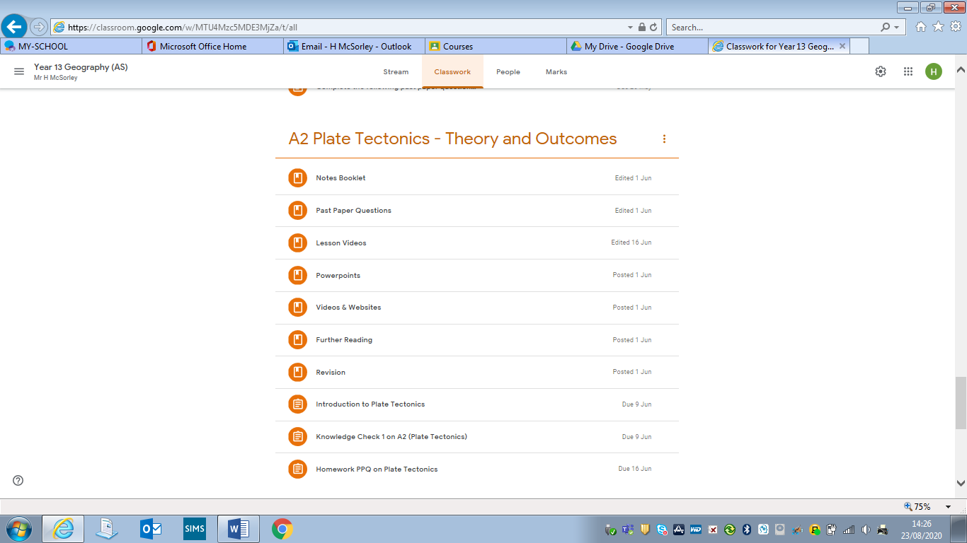

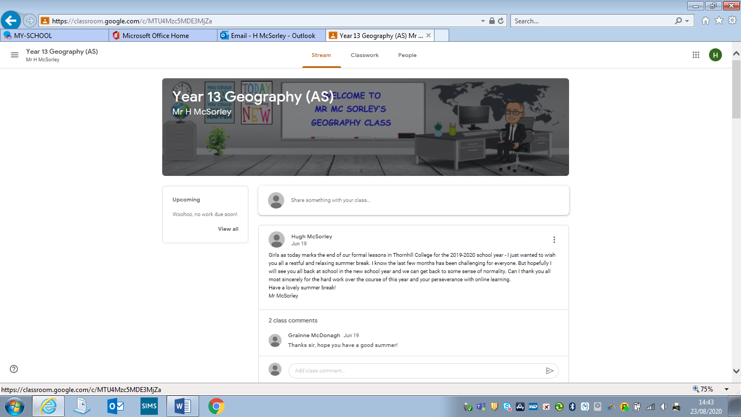
3) If you have any assignments / homeworks which have been posted for you to complete you can also see them listed in the Upcoming / To Do list on the left hand side of the Stream page.

4) If you want to see all the assignments / homeworks that you have been set in this google classroom click on View All. You will then get a list of them like below:

If you click on:

All – You will see all the assignments you have been set in this google classroom.

Assigned – You will set assignments you have been set but you have not completed yet as you still have time before the deadline for them to be handed up.

Returned – You will see assignments which you have submitted to your teacher and they have returned them with marks / feedback.
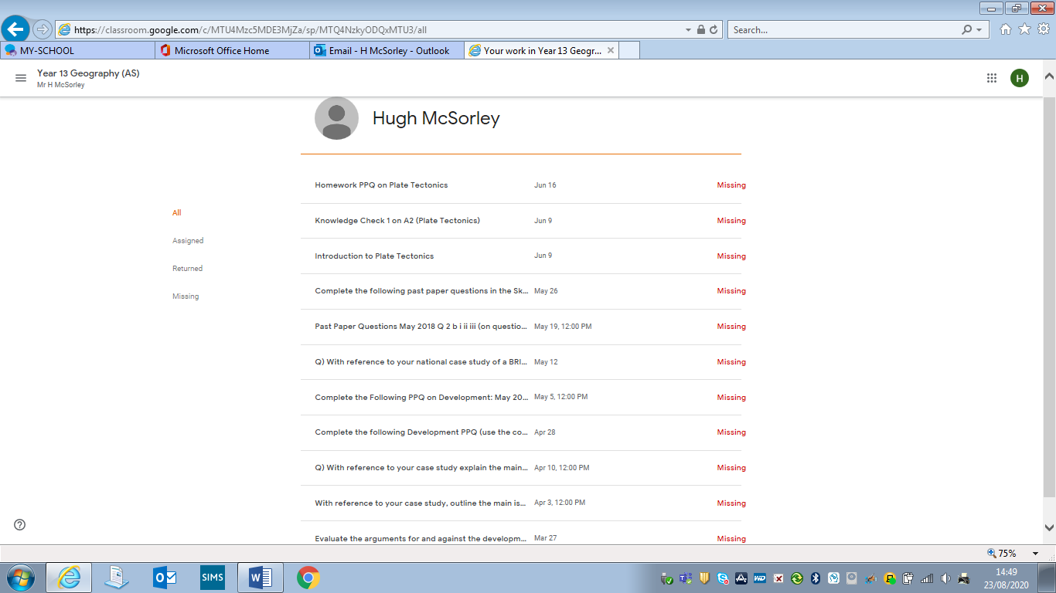

5) If you click on a particular assignment / homework – it will let you view any work you submitted.

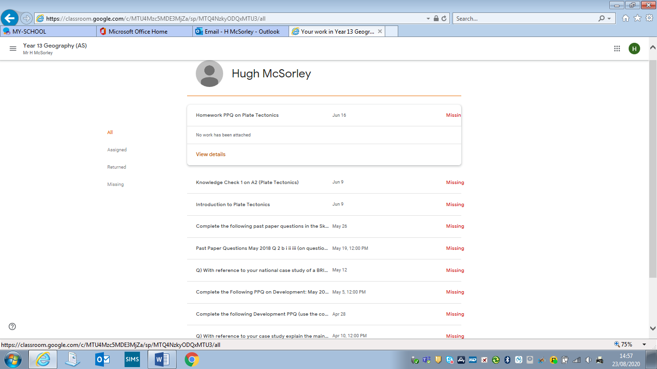

6) If you wish to submit a piece of work for this homework / assignment - click on View Details. This will take you to the instructions which were given for this homework and allow you to submit your work for it.

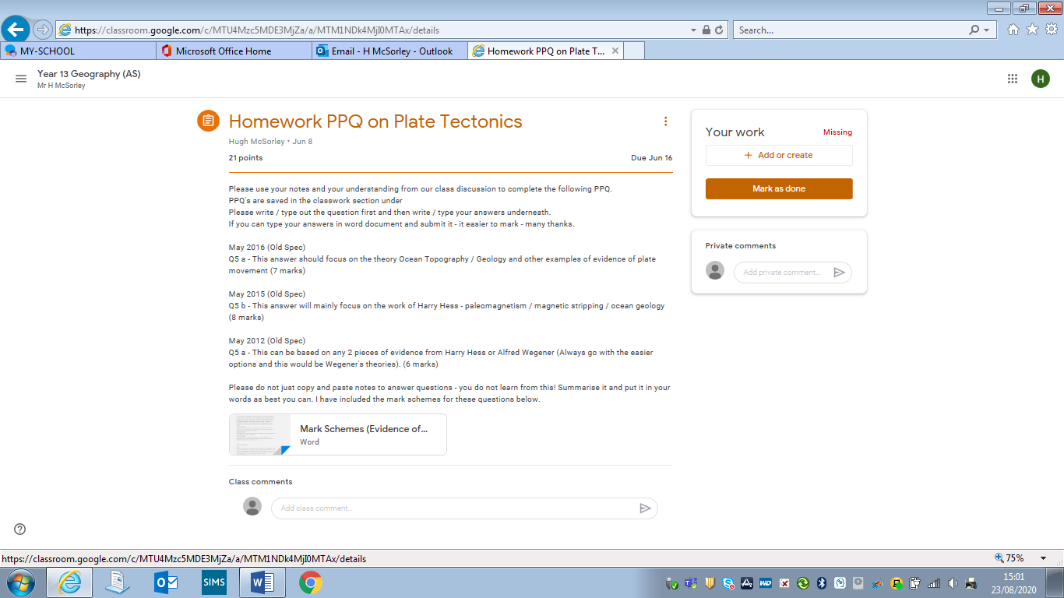
7) To submit your work for an assignment which has been set. Click on + Add or create.

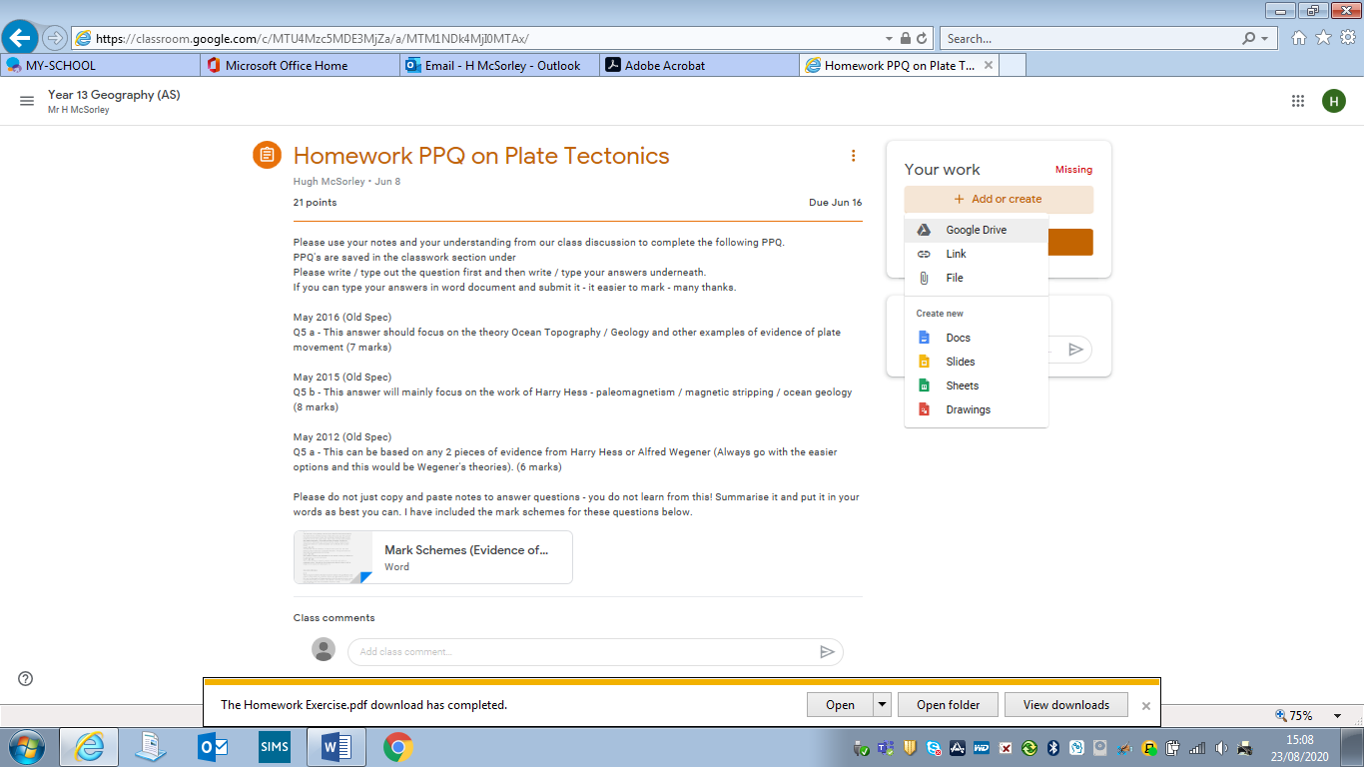
8) You will then be given a list of options of the type of file your work is saved in which you wish to submit.

9) Click on File.
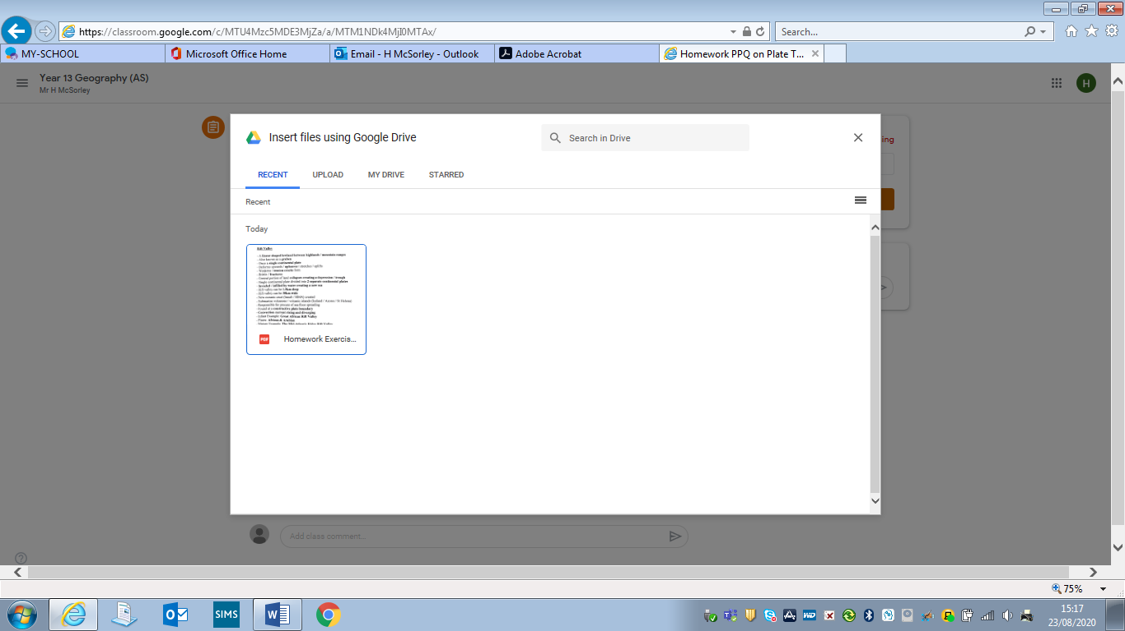

10) You can then click on Upload to upload a document you have saved on your computer to submit as your work for the assignment.
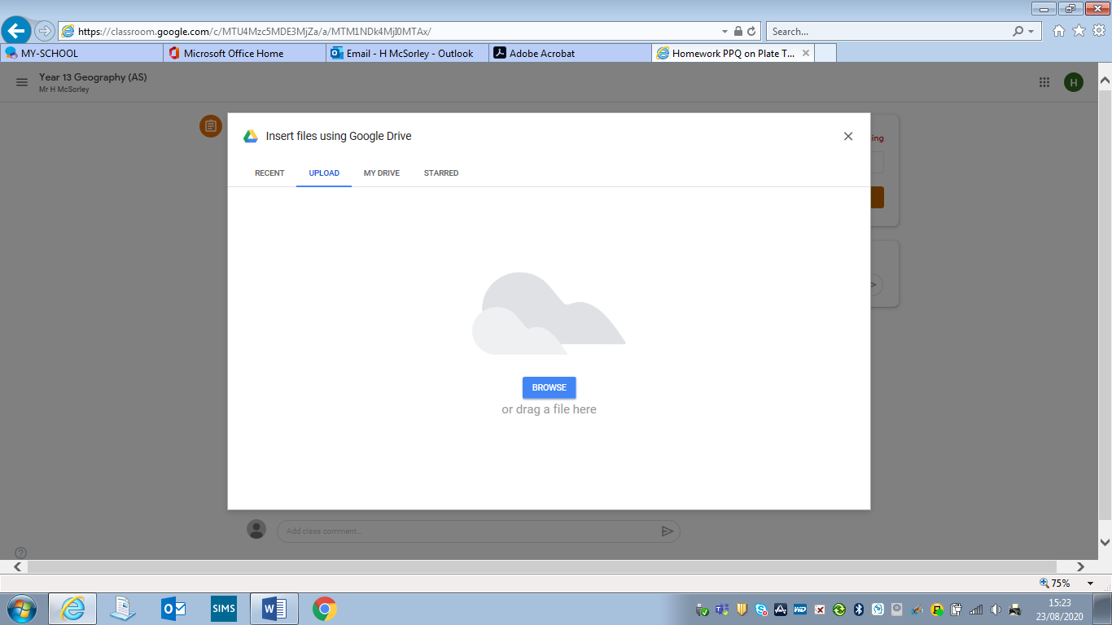

Click on Browse.
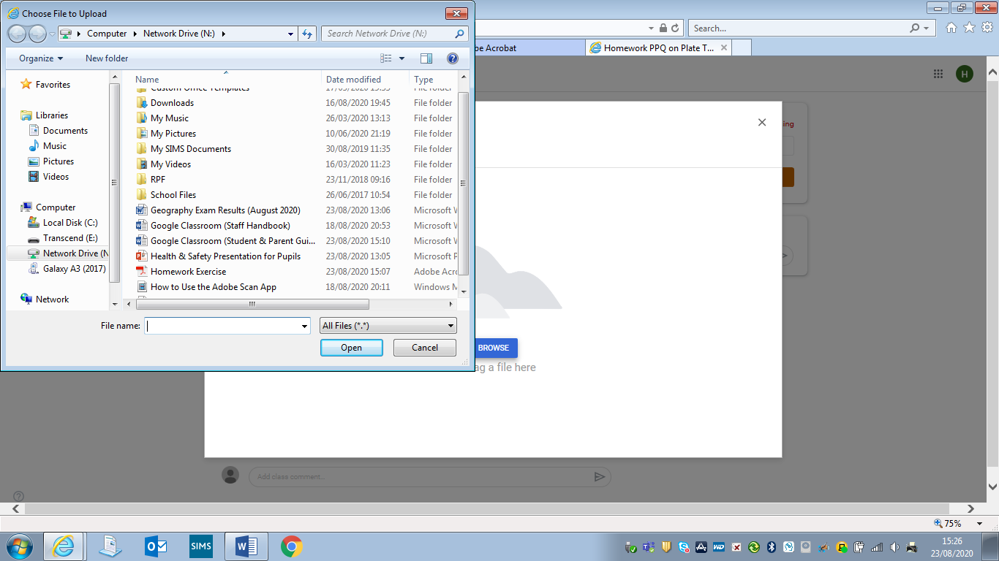
Search for the document / file you wish to upload as your homework. Click on the file, then click on Open. This will now add this file to the assignment as your homework for it.

OR
You can click on My Drive if you wish to upload a document you have saved in your Google Drive to submit as your work for the assignment.

11) You will now see the document / file uploaded to the assignment set. To submit it to your teacher, click on Turn in.
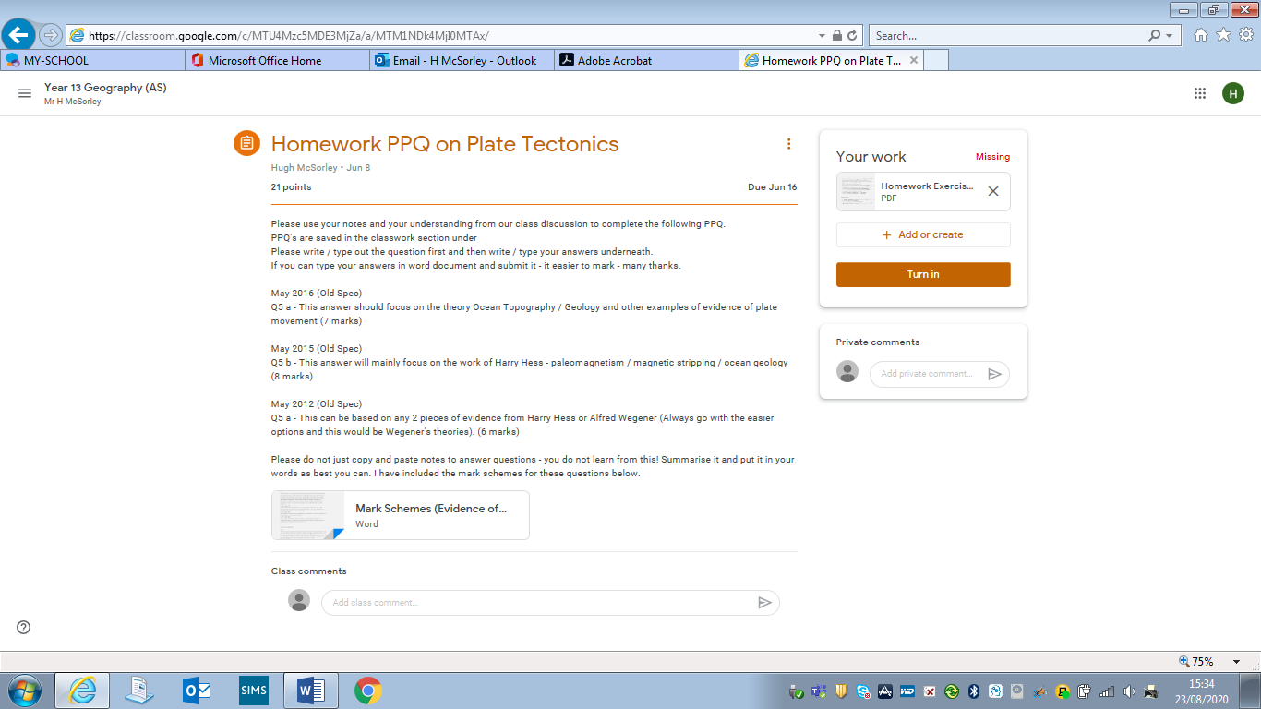

You will be asked to confirm you want to turn in / submit this work to your teacher. Click on Turn in.

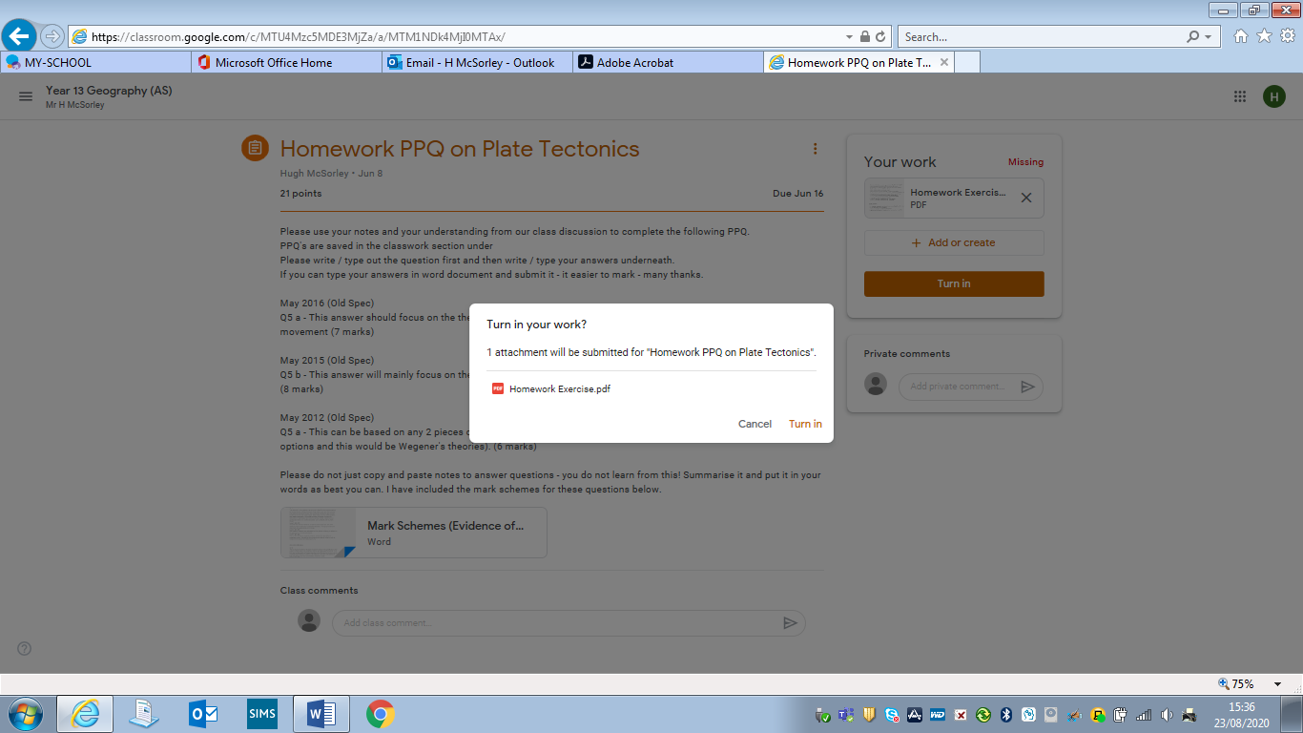

12) You work has now been submitted to your teacher. If you wish to send them a private message about the work. You can do so by typing it in the section Private Comments and click on the arrow icon to send it.

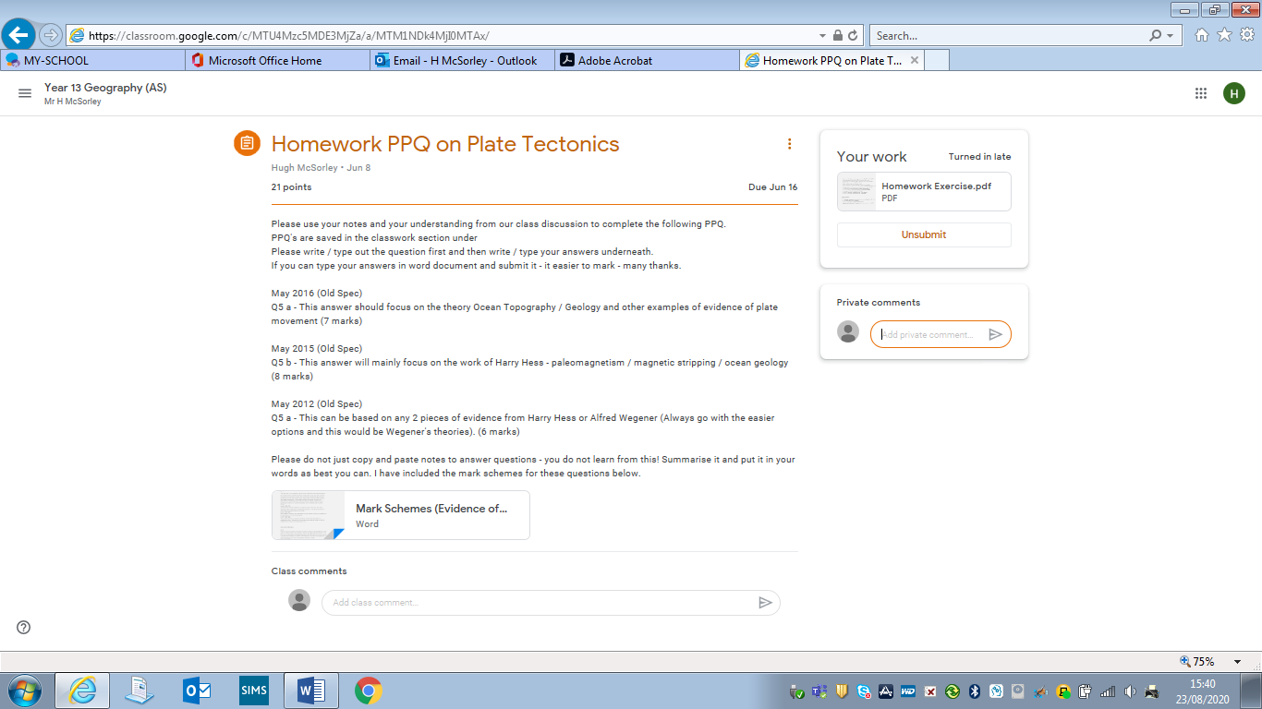

Part 6 - Using Adobe Scan to Submit Hand-Written Work or Completed Worksheets

When submitting multiple pages of work to a teacher of completed worksheets or written answers or essays it is best to submit it as a single pdf document as it will be easier for them to read and mark it and for you to see the feedback on it. To do this you can use an app called Adobe Scan. You can download this app to your smart phone or tablet for free using the App Store for iPhones or iPads and Playstore for other smart devices.

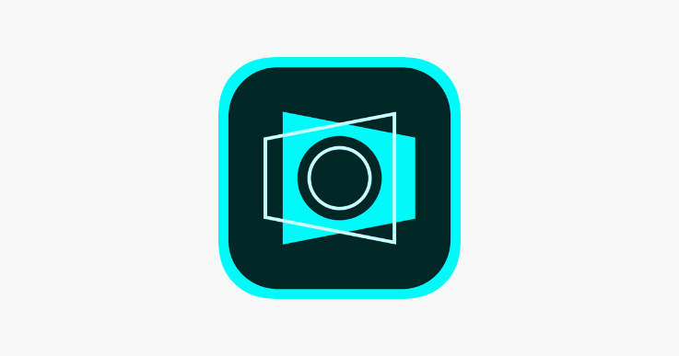


1) When you have downloaded the Adobe Scan app to your phone. Open the app. It will now ask you to sign in using either a google account or apple account you have.

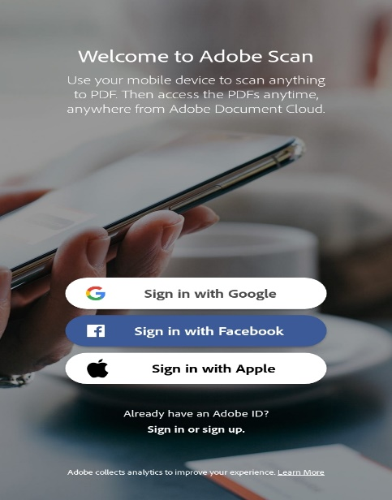

2) To sign in with a google account – click on Sign in with Google.

3) Enter your google email address and click on Next.

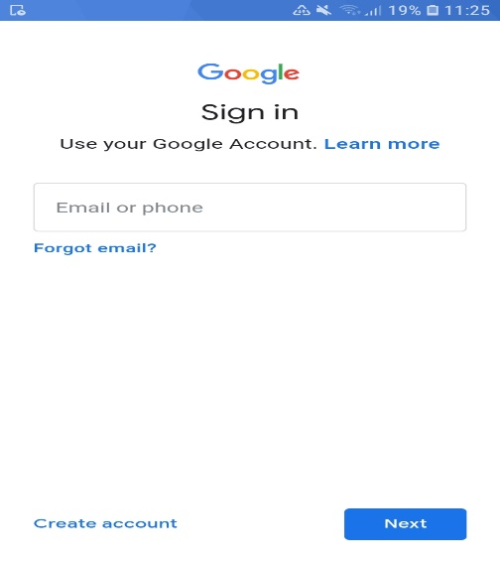

4) Complete your registration but noting your date of birth and click Done.
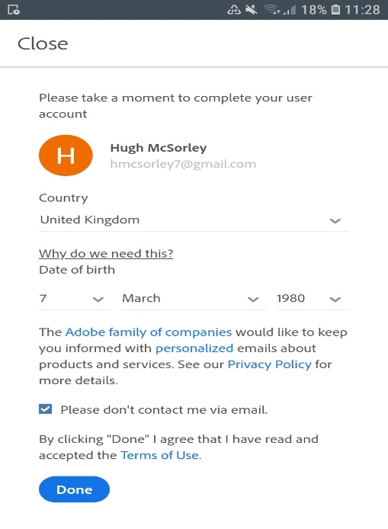

5) You will now be ready to start using Adobe Scan. Click on Let’s Go on the first screen that appears and then Allow for Adobe Scan to have access to your camera.

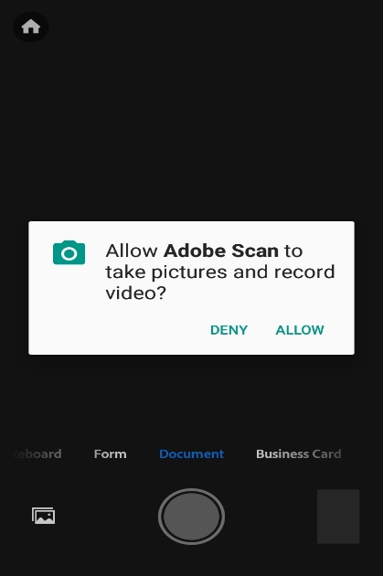
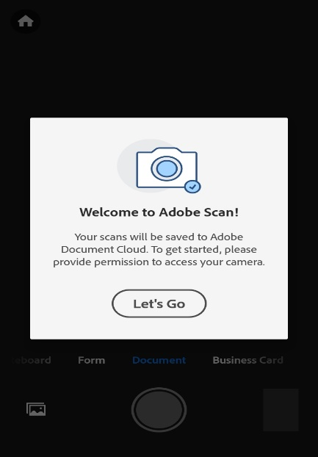

6) Now place your phone over the first page of your work you wish to scan. You can either click on the camera button at the bottom of your screen or touch the screen of the camera image itself to take a photo.
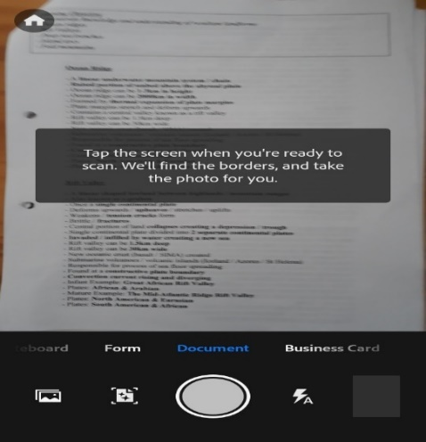

7) An image of the document will now appear on your screen with a blue frame. You can move the borders to select the area of the document you wish to crop. When you are happy with it click Continue.
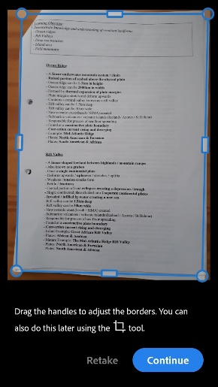

8) You can now take a photo for another page and again crop the photo taken. You can repeat this for as many pages as necessary.

9) Each photo will be added to an icon on the bottom right of the screen, so you know how pages you have scanned. When you have finished scanning the pages you want to, click on this icon

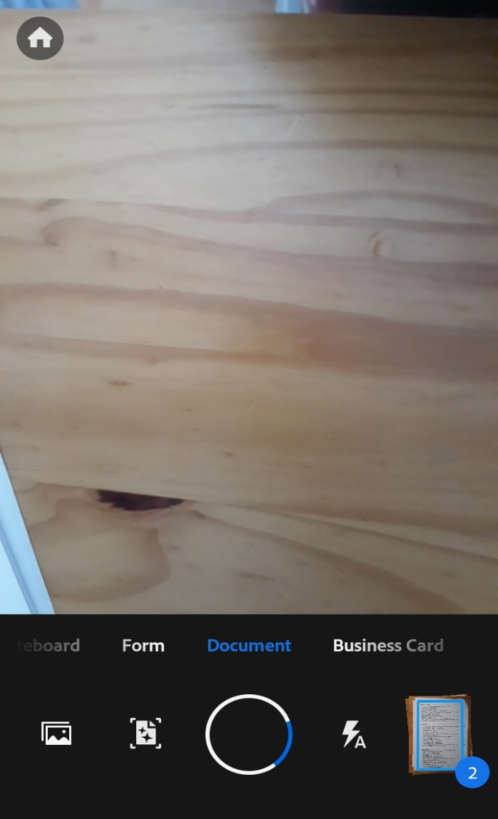

10) This now generates a preview of the pages you have scanned, which you can flick between by swiping right and left on the screen.

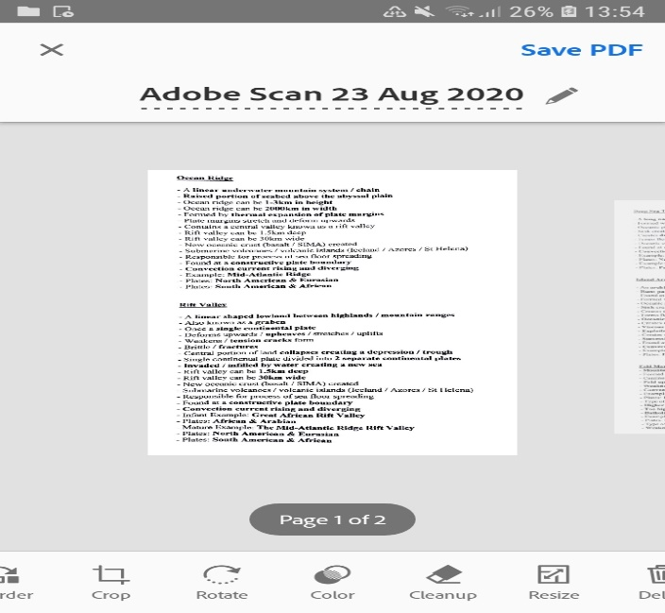

11) To generate a single pdf document containing all these pages click on Save PDF at the top right of the screen.

12) You can now email this pdf document to yourself by clicking on Share and email.
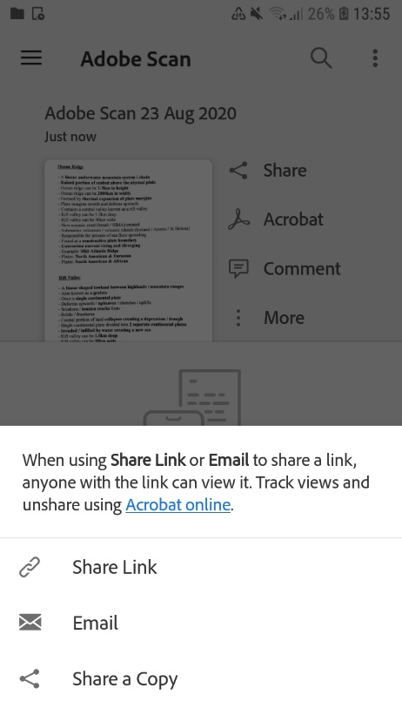

13) Or you can add / save the pdf document to your Google Drive by clicking on More and Copy to….
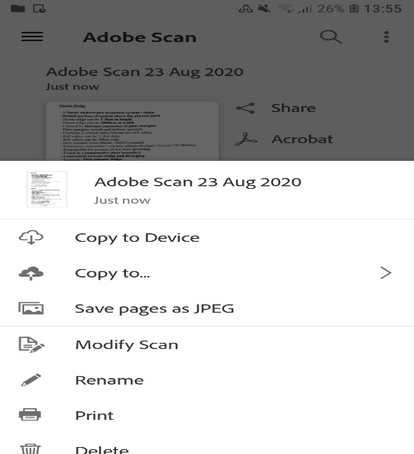

Part 7 – Accessing Feedback on Assignments

1) To access the feedback on a homework. Firstly, open the Stream of a google classroom.
2) Underneath Upcoming – click on View All.
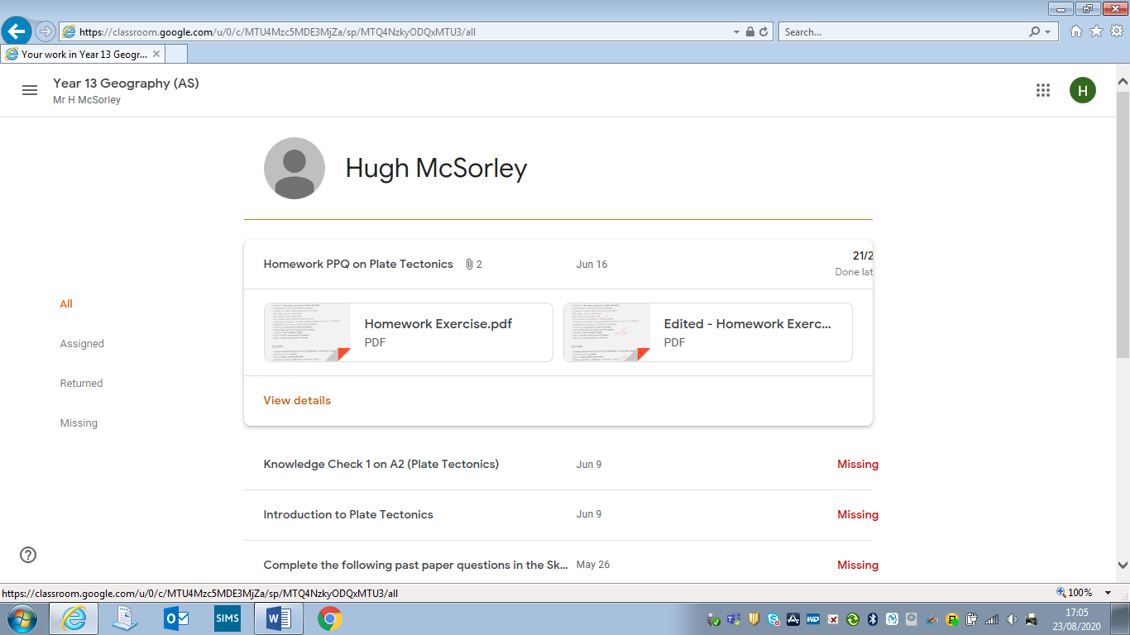
3) Click on the homework completed. You will see the work you have handed up and if the teacher has added hand written comments to your work you will also see an edited version of the pdf as well. Click on View Details.
4) To view the written feedback of your teacher click on the edited pdf. You will also see the mark you received for the work at the top of the screen.
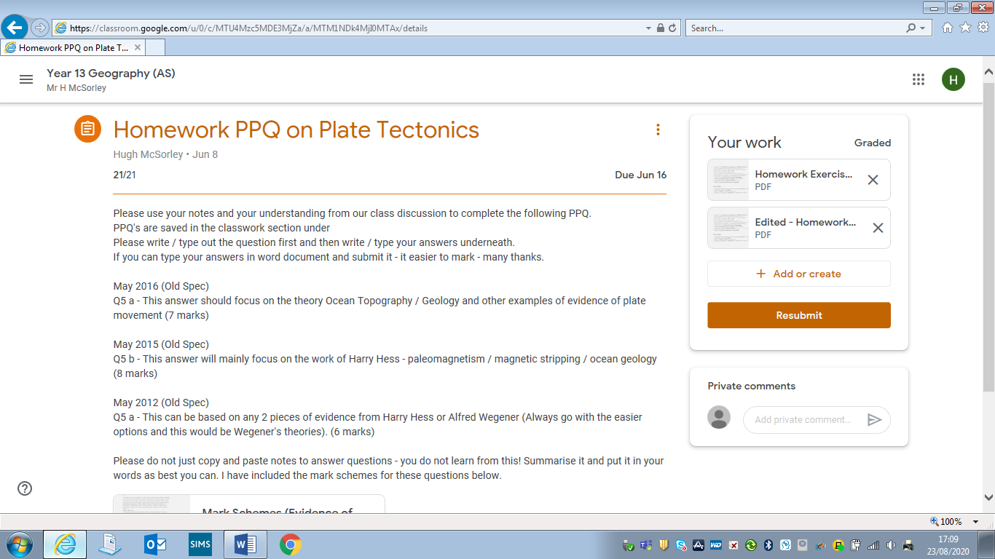

5) This will open up your work with your teachers handwritten comments (like below).
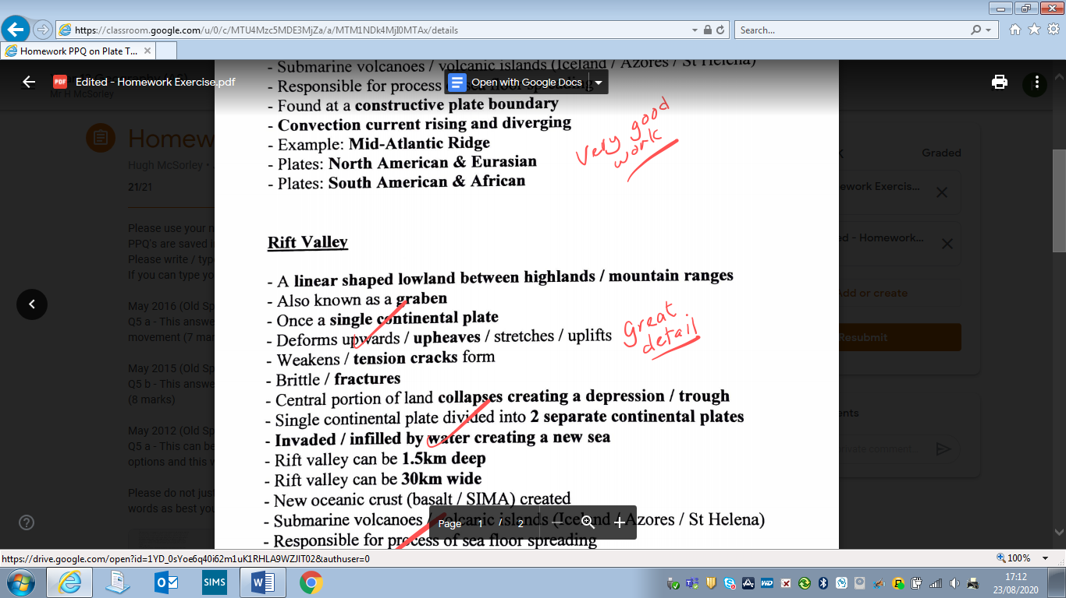

6) If your teacher adds typed comments to your work instead of handwritten ones there will not be an edited version of your work. So just click on your original pdf document your submitted.

7) When your work opens up click on the 3 dots at the top right of the page.
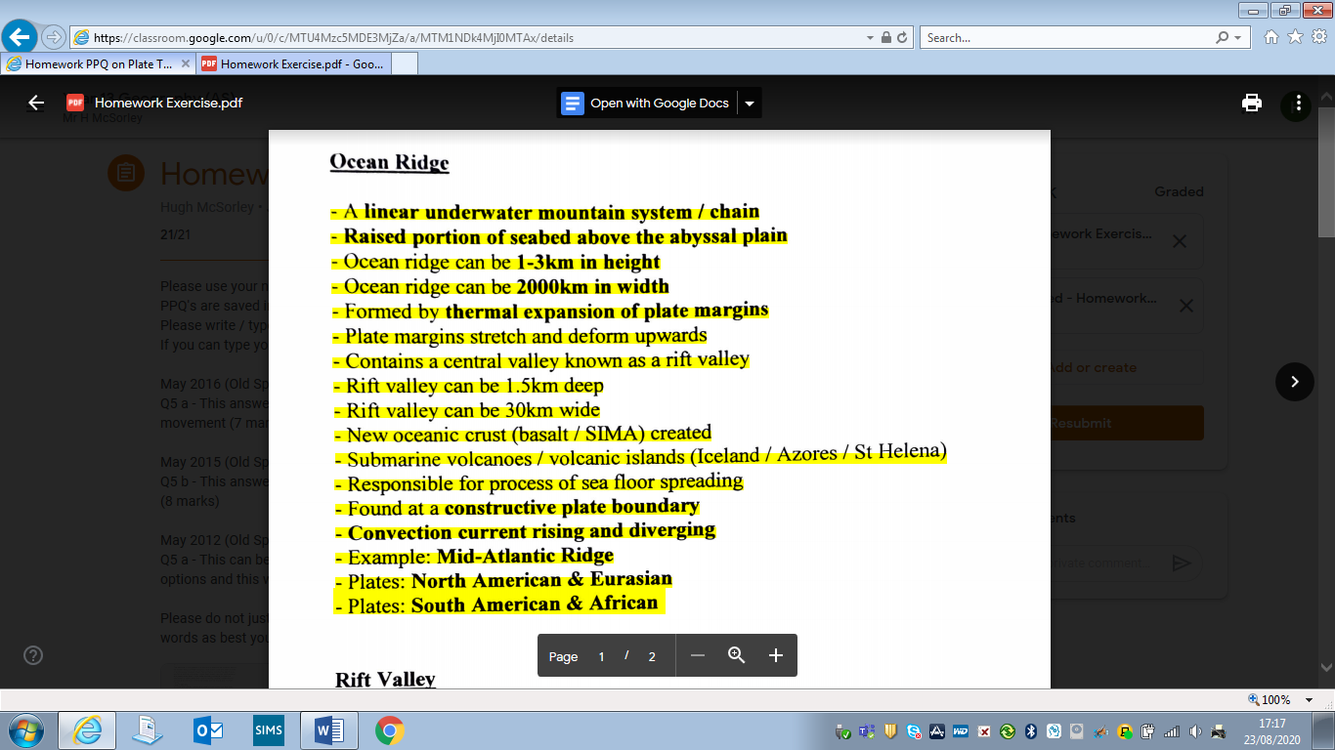

8) Click on Open in New Window.

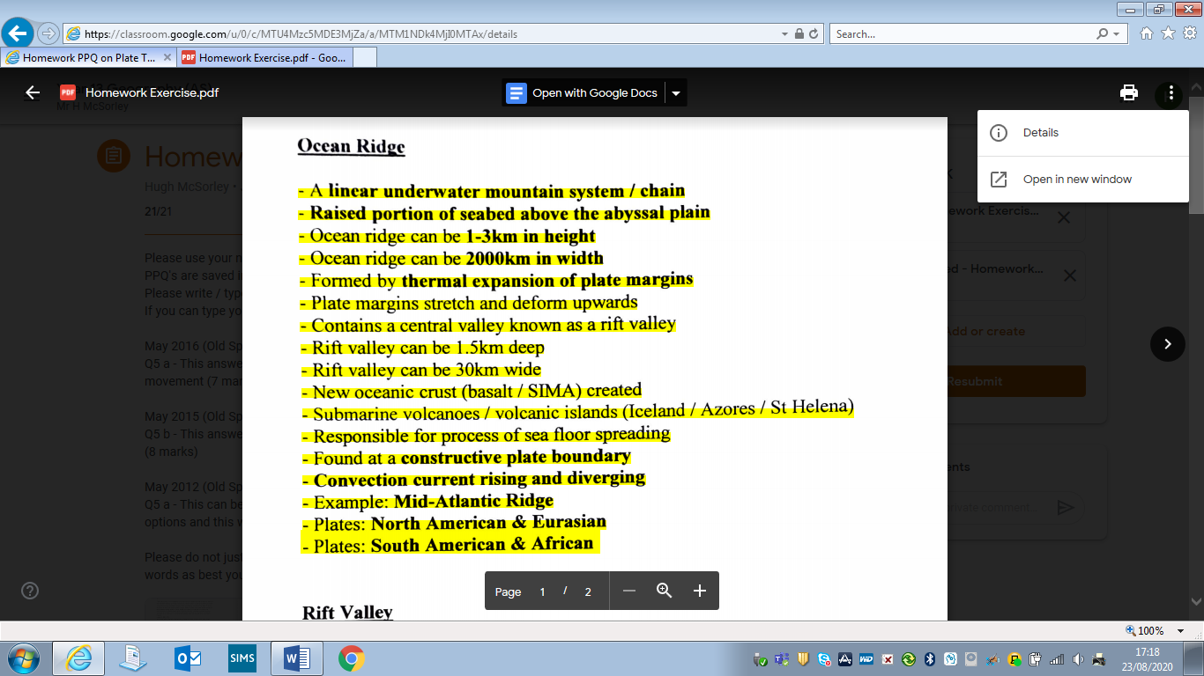

9) You will now be able to scroll down through your work and see any typed feedback / comments along the right hand side of the page (like below).

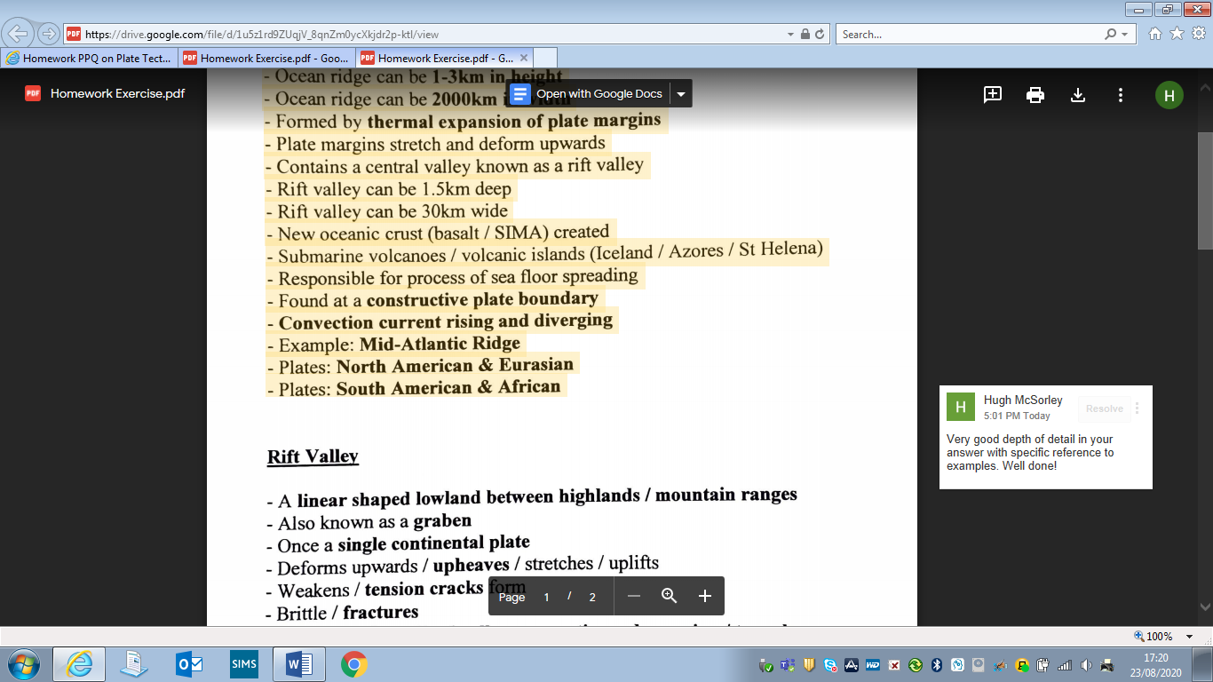

Part 8 – Managing All Your Assignments

When you open google classroom and can see all the classrooms you are a member of, there is a tab at the top of the screen which says To Do. If you click on this – you will be able to see all the assignments, you have been set to complete in all the different subjects you have a google classroom for.

This is an easy way to manage your work load across all your subjects and make sure you have all your work completed on time. You can also click on the calendar which will show you the deadlines for each of your assignments set across all your subjects.

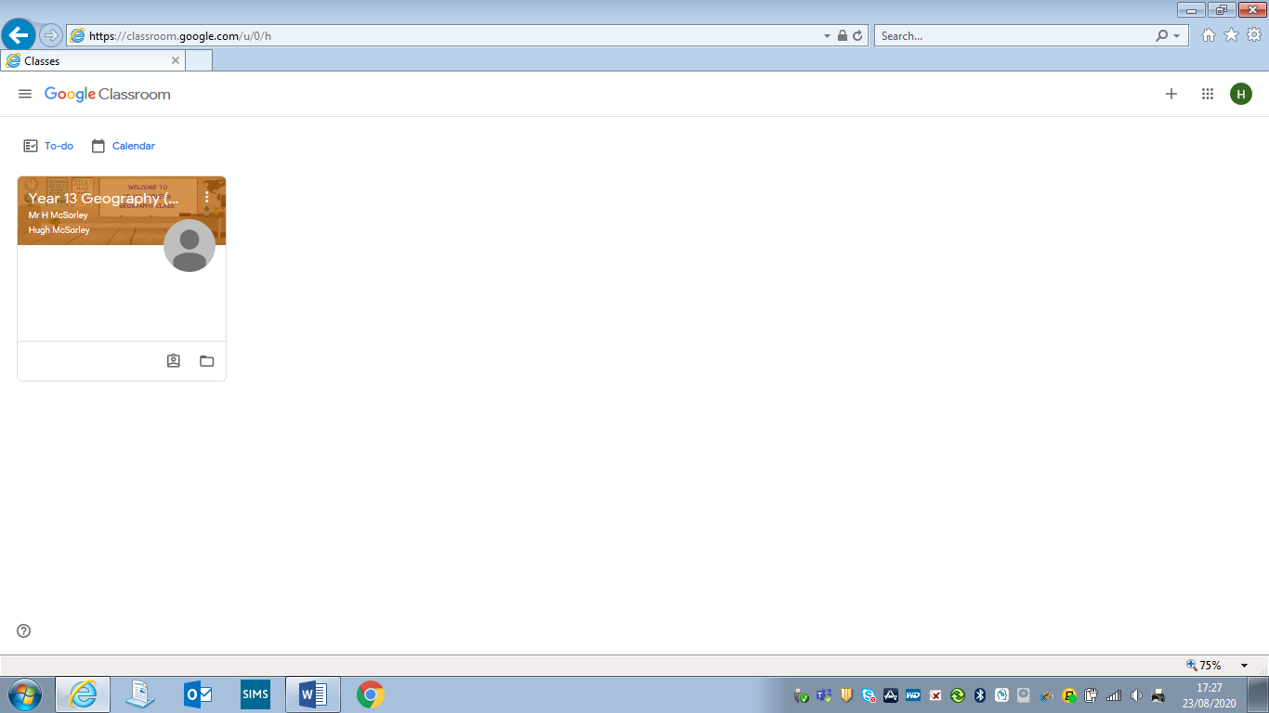

Part 9 – Using Your Mobile Phone for Google Classroom

If you have the google classroom app downloaded onto a phone, iPad or tablet you will receive a notification if a teacher posts a message on the Stream, a private message to you or if they post an assignment for you to complete.

1) You can download the Google Classroom app for free to your smartphone, iPad or tablet from the App Store or Play Store. Just search for Google Classroom and click on Open or Install.
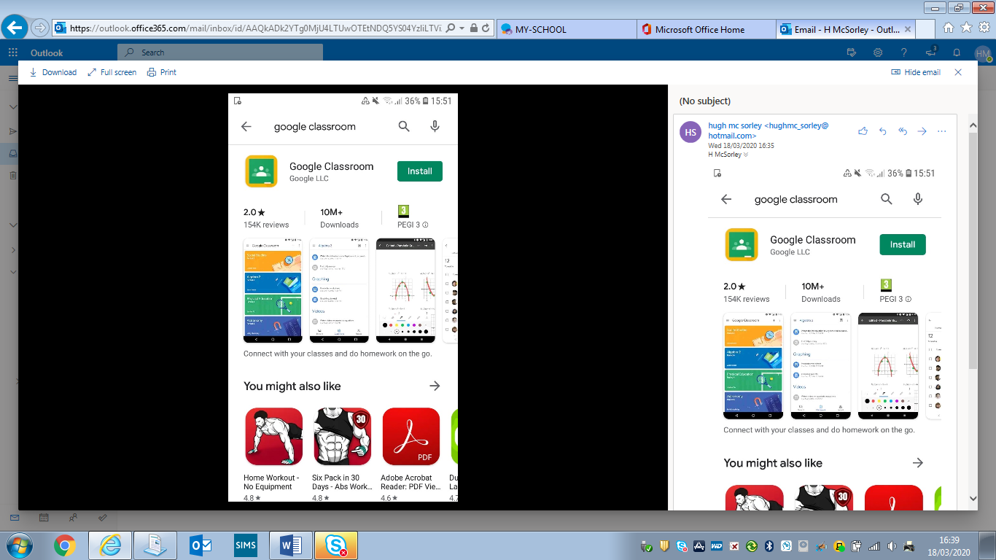

2) The Google Classroom app will be addded to your home screen, click on it to open it.

3) Click on Get Started.
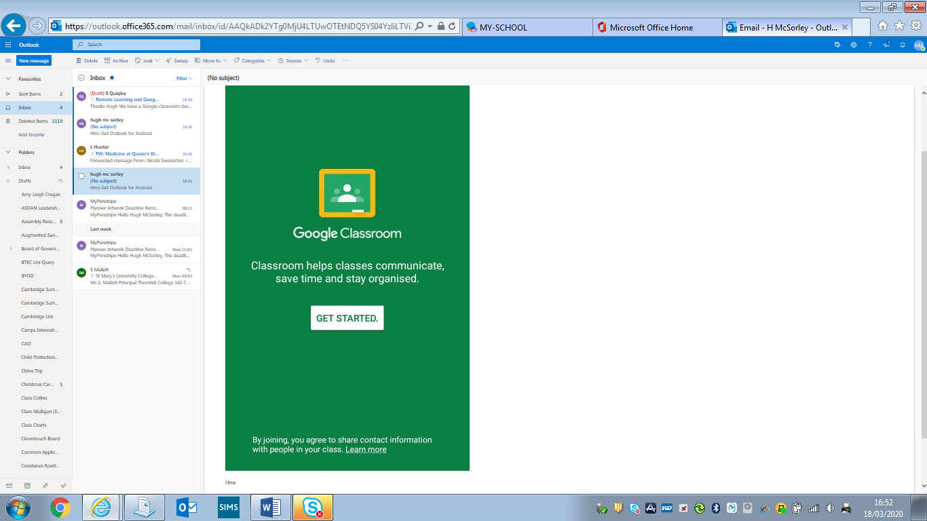

4) Click on Add account and OK.

5) You will be asked to sign in with an email address using your Google Account. We are insisting you use your school email address to keep the all communication through your school account rather than any personal email address for your online safety. Enter your school email address making sure it ends in @c2ken.net for example hmcsorley818@c2ken.net and click on Next.

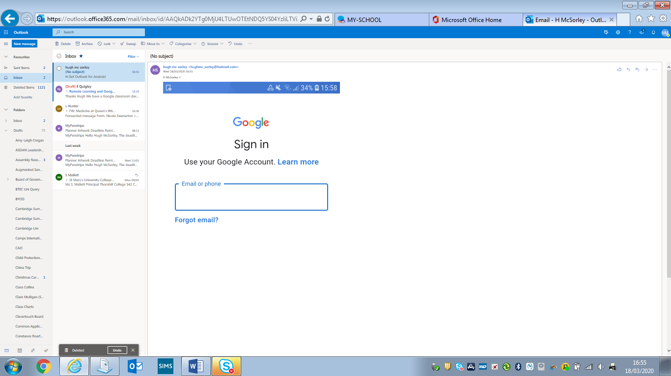

6) You will get a message noting your school google account is managed by c2ken.net and the relevant terms and conditions. Click on Accept.

7) The following screen may appear and you will be prompted to sign in. Enter your school email address making sure it ends in @c2ken.net for example jbloggs818@c2ken.net Then type in your normal c2k password for logging on to the computers at school and click Sign in.

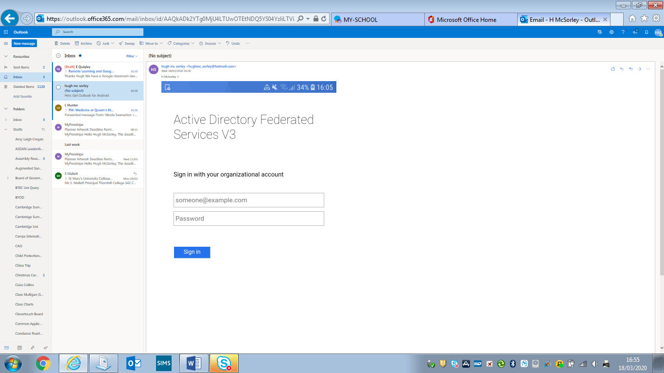

You will now be signed into Google Classroom on the app on your phone and can use it as outlined above with the Stream for communication and Classwork for accessing learning resources.

Once you have downloaded the app and signed in, you will not need to sign into Google Classroom each time you use the app on your phone. It should automatically open up with the rooms you have joined. Simply click on a room to open it.

